Clustering and Predictive Modelling of Cryptocurrencies:
An Empirical Study of Lead–lag Dynamics and Forecasting Performance

Viktor Varga

A Thesis Submitted in Partial Fulfilment
of the requirements for the
Degree of
Master of Science in Data Analytics



September 2025

Supervisor: Kashif Qureshi

Table of Contents
Abstract 5
Chapter 1: Introduction 6
1.1 Overview 6
1.2 Introduction 6
1.3 Problem Background 7
1.4 Problem Statement 7
1.5 Research Questions 8
● RQ1: 8
● RQ2: 8
● RQ3: 8
1.6 Research Objectives and Measurable Outcomes 8
● Research Objective 1: 8
● Research Objective 2: 8
● Research Objective 3: 9
1.7 Relevance of the Study 9
1.8 Research Scope 10
1.9 Thesis Organisation 10
Chapter 2: Literature Review 12
2.1 Overview 12
2.2 Introduction 12
2.3 Applications 12
2.3.1 Lead–lag Analysis Applications 13
2.3.2 Predictive Modeling Applications 13
2.4 Challenges 14
2.4.1 Volatility and Noise 14
2.4.2 Clustering Difficulties 14
2.4.3 Lead–lag Detection Challenges 14
2.4.4 Forecasting and Modeling Challenges 15
2.5 Literature Review 15
2.5.1 Time-Series Clustering 15
2.5.2 Lead–lag Relationships 16
2.5.3 Machine Learning for Price Prediction 17
2.6 Discussion 18
Chapter 3: Research Methodology 19
3.1 Overview 19
3.2 Research Design and Framework (CRISP-DM) 19
3.3 Data Source and Environments 21
3.3.1 Data Source 21
3.3.2 Programming Environment 21
3.3.3 Notebook Environment 21
3.4 Performance Parameters 22
3.5 Ethical Considerations 23
Chapter 4: Design and Development 24
4.1 Overview 24
4.2 System Architecture 24
4.3 Architectural Choices 26
4.4 Justification of Binance API, Data Storage Formats, and Reproducibility 27
4.5 Data Design and Preprocessing 27
4.5.1 Data Collection - Secondary Data 27
4.5.2 Data Cleaning 28
4.5.3 Feature Engineering - Primary Data 29
4.6 Exploratory Data Analysis after Data Preparation 30
4.6.1 Initial correlation scan 30
4.6.2 All-pairs cross-correlation 30
4.6.3 Correlation matrix on log returns 31
4.6.4 Filtering Candidate Lead–Lag Relations 32
4.6.5 Granger causality and VAR validation 32
4.6.6 Normalisation before DTW 33
4.6.7 Justification for Robust Scaler 35
4.7 Data Preparation for Clustering 35
4.7.1 Outliers Winsorisation 35
4.7.2 Outlier-Resilient Normalisation via Robust Scaling 35
4.8 DTW Clustering of Hourly Returns 37
4.9 DTW-Based Lead–Lag Analysis 37
4.9.1 Preparation of Return Series for Lead–Lag Detection 37
4.9.2 Pairwise DTW-Based Lag Estimation 37
4.9.3 Leader-Lag Score Computation 38
4.9.4 Validation with Granger Causality 38
4.9.5 DTW Lead–Lag Conclusion 39
4.10 Forecasting with Traditional Time-Series Models 39
4.10.1 Persistance 39
4.10.2 Ridge Regression - Single-Leader 39
4.10.3 Ridge Regression - Multi-Leader 39
4.10.4 Common Protocols applied for Persistence and Ridge 40
4.10.5 ARIMAX With All DTW Leaders 40
4.10.6 ARIMAX With Positive DTW Leaders Only 40
4.10.7 Common protocol for ARIMAX models 40
4.11 Forecasting with Deep Learning Models (LSTM) 41
4.11.1 LSTM Data Preparation and Exploratory Analysis 41
4.11.1.1 LSTM Target and Leader Asset Definition 41
4.11.1.2 Forecast Horizons and Construction of Lagged Features 41
4.11.1.3 Chronological Splitting and Target–Feature Separation 41
4.11.1.4 Normalisation - Robust Scaler 43
4.11.1.5 Dimensionality Reduction - Principal Component Analysis (PCA) 44
4.11.1.6 Exploratory Summary 45
4.11.2 LSTM Sequence Construction 45
4.11.3 LSTM Model Construction and Training 45
4.11.4 Hyperparameter Tuning Strategy 45
4.11.4.1 Stage 1 - Random search (coarse exploration). 46
4.11.4.2 Stage 2 - Grid search (local refinement). 46
4.11.5 LSTM: Rolling-Window Evaluation 46
4.12 Workflow Checkpointing and Computational Strategy 47
4.13 Design and Development Summary 47
Chapter 5: Results and Conclusion 49
5.1 Guiding Questions and Objectives 49
5.2 Results 49
5.2.1 Clustering of Cryptocurrency Assets 49
5.2.2 Lead–Lag Dynamics 51
5.2.3 Predictive Modelling 52
5.2.3.1 Persistence - Evaluation. 52
5.2.3.2 Ridge Regression- Evaluation. 52
5.2.3.3 ARIMAX - Evaluation. 53
5.2.3.4 LSTM Before Hyperparameter Tuning - Evaluation. 55
5.2.3.5 LSTM After Hyperparameter Tuning - Evaluation. 55
5.2.3.6 LSTM with Rolling-Window Evaluation. 56
5.3 Comparative Performance of Forecasting Models 57
5.4 Discussion 58
5.5 Conclusion 59
5.5.1 RQ1 - Clustering 59
5.5.2 RQ2 - Lead–lag dynamics 59
5.5.3 RQ3 - Forecasting 59
5.6 Future Work 61
6. References 62

Abstract

Cryptocurrency markets pose analytical challenges due to their volatility, non-stationarity, and complex interdependencies. Traditional econometric models have struggled with these features, while machine learning models often face overfitting and limited interpretability. This thesis has developed an integrated framework combining clustering, lead–lag detection, and predictive modelling to examine whether structural and temporal dependencies in cryptocurrency markets can improve forecasting performance.

Hourly OHLCV data for a selection of liquid cryptocurrencies from the Binance API over a thirteen-month period has been analysed. Dynamic Time Warping (DTW) has been used to identify asset clusters, while cross-correlation, Granger causality, and Vector Autoregression (VAR) have been tested for leader–lagger dynamics. Forecasting models, including Persistence benchmarks, Ridge regression, ARIMAX, and Long Short-Term Memory (LSTM) networks, have been evaluated for predictive accuracy with and without leader signals.

The results have shown that clustering yields largely homogeneous groupings, reflecting the synchronous nature of cryptocurrency markets. Lead–lag analysis has revealed occasional leader–follower relationships, though these have been unstable and regime-dependent. Predictive modelling has indicated that Ridge regression offers negligible gains, and while LSTM networks have captured some non-linearities, overall improvements over baselines remain modest. Leader signals have not consistently enhanced forecasting accuracy.

The study’s contribution lies in presenting a reproducible analytical pipeline that integrates descriptive and predictive approaches within a single framework. While predictive gains have been limited, the framework offers a foundation for future research incorporating macroeconomic indicators, sentiment analysis, or regime-switching models.

Chapter 1: Introduction

1.1 Overview
The rapid expansion of cryptocurrency markets has created both opportunities and challenges for investors, analysts, and researchers. Cryptocurrencies exhibit high volatility, complex interdependencies, and regime shifts that complicate traditional approaches to financial modelling. As such, new analytical frameworks are needed to understand market structures, detect temporal dependencies, and evaluate predictive potential in these turbulent environments. This thesis examines whether clustering, lead‑lag detection, and predictive modelling can be integrated into a single framework to generate both descriptive and predictive insights into cryptocurrency behaviour.

1.2 Introduction
Cryptocurrencies have evolved from niche digital assets into a significant component of the global financial system. Their decentralised and continuously traded nature has attracted extensive research interest, yet their unpredictability makes forecasting particularly difficult. A cryptocurrency is a digital asset recorded on a distributed ledger, secured by cryptography, and designed to serve as a medium of exchange. Unlike traditional financial instruments, cryptocurrencies trade continuously across global markets, exhibiting high volatility and frequent structural shifts.

Previous studies have approached the forecasting challenge from separate angles: clustering has revealed structural relationships among assets (Sigaki et al., 2019), lead–lag analysis has explored temporal dependencies (Sifat et al., 2019), and machine learning methods have been applied to prediction tasks (Murray et al., 2023). Dynamic Time Warping (DTW), one of the central methods in this thesis, is a distance measure that aligns two time series by stretching or compressing the time axis, enabling the detection of similarities even when events occur at slightly different times. Lead–lag dynamics describe situations in which movements in one asset consistently precede those in another, suggesting directional influence or predictive potential.

Despite these contributions, the approaches have rarely been integrated, leaving a gap in understanding how descriptive relationships translate into predictive value (Bennett et al., 2022). This research addresses that gap by combining time-series clustering, lead–lag analysis, and forecasting models in a reproducible pipeline. In doing so, it seeks to examine not only whether meaningful structural and temporal relationships exist but also whether these can be leveraged to improve predictive performance.

1.3 Problem Background
Financial time series are known to be noisy and non-stationary, but cryptocurrencies amplify these difficulties due to their high volatility, speculative trading, and frequent market shocks (Wątorek et al., 2023). High volatility generates abrupt price swings that can obscure underlying patterns, while speculative trading often detaches market movements from fundamental drivers, producing dynamics that are difficult to capture with statistical or machine learning models. These features increase the risk of overfitting and reduce the stability of predictive relationships across different regimes.

While clustering has been used to detect structural relationships between assets, results have often indicated weak separability, with cryptocurrencies moving largely as a single cohesive market (Šťastný et al., 2022). Similarly, attempts to identify leader–lagger dynamics have shown that relationships are often unstable, bidirectional, or regime-dependent (Guan et al., 2024). Predictive modelling has been further constrained by these challenges, as linear models such as ARIMA or Ridge regression have struggled with volatility (Wu et al., 2024), and non-linear methods such as Long Short-Term Memory (LSTM) networks have provided only modest improvements (Bouteska et al., 2024). The lack of integrated studies that connect these three analytical perspectives has motivated this research.

1.4 Problem Statement
Although clustering, lead–lag detection, and predictive modelling have each been applied to cryptocurrency data, the absence of a combined approach limits both theoretical understanding and practical application. Current literature has shown that clusters are weakly defined, lead–lag effects are fragile, and predictive gains are often marginal (Šťastný et al., 2022; Sifat et al., 2019). The central problem addressed in this thesis is whether integrating these methods into a single pipeline can provide more robust insights into cryptocurrency market behaviour and improve short-horizon forecasting performance.

1.5 Research Questions
This research has been guided by three core questions.

RQ1:
To what extent can clustering based on Dynamic Time Warping (DTW) reveal meaningful groupings of cryptocurrencies with similar return behaviours?

RQ2:
Do cryptocurrencies exhibit consistent leader–follower dynamics, and if so, how stable and statistically significant are these relationships across different assets and time horizons?

RQ3:
Can predictive models, including neural networks enhanced with leader signals, achieve improvements over simple statistical baselines in forecasting cryptocurrency returns?

1.6 Research Objectives and Measurable Outcomes
To address these questions, the study has set the following objectives.

Research Objective 1:
Apply unsupervised learning to group cryptocurrencies according to similarities in their return series. This will involve applying a clustering approach based on Dynamic Time Warping (DTW) to identify groups of assets that exhibit similar trends, volatility patterns, or reactions to market events.
Measurable outcome 1:
Clusters assessed using internal validation indices (e.g., silhouette score) and examined for interpretability in relation to observed market behaviours.

Research Objective 2:
Explore temporal relationships within and across clusters to determine whether certain cryptocurrencies consistently move ahead of others. Analytical techniques will include cross-correlation analysis, Granger causality testing and vector autoregression (VAR) models.
Measurable outcome 2:
Statistical tests of lead–lag effects (cross-correlation, Granger causality) with significance and stability evaluated.

Research Objective 3:
To develop forecasting models - including baseline comparators and an LSTM - to predict cryptocurrency returns using both endogenous and exogenous inputs, and to evaluate these models against one another to compare forecasting performance.
Measurable outcome 3:
Forecasting accuracy evaluated using RMSE, MAE, and directional accuracy, with comparative analysis against baseline models to determine the contribution of lead–lag features.

Together, these objectives establish the analytical foundation of the thesis, linking clustering, temporal analysis, and forecasting within a single framework. The following section highlights why pursuing these objectives is both theoretically important and practically relevant.

1.7 Relevance of the Study
Understanding how cryptocurrencies interact has been not only a theoretical exercise but also a practical necessity. Investors have sought to detect early movers to anticipate market shifts, regulators have been concerned with systemic risk arising from highly interconnected markets, and researchers have explored whether insights from clustering and lead–lag analysis can inform predictive models. This study has contributed by demonstrating an integrated pipeline that has offered descriptive insights into market structure and has evaluated their predictive potential. While predictive gains have been modest, the reproducible framework has provided a foundation for future research, including extensions with macroeconomic indicators or sentiment data. The study has been particularly relevant given the nature of cryptocurrency markets. These markets have been extremely volatile and often inefficient, with research suggesting that a significant portion of price movements has been driven by noise (Wątorek et al., 2023). Figure 1.1 has shown Bitcoin’s price volatility over the past 12 months, highlighting the frequent and unpredictable fluctuations that have characterised the market (Binance, 2025). This has created opportunities to uncover patterns, such as assets that have consistently moved ahead of others.

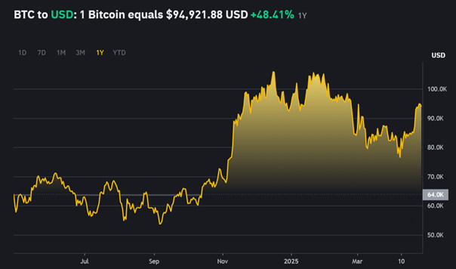
Figure 1.1. Bitcoin price volatility over the past 12 months (Source: Binance, 2025).

1.8 Research Scope
The study has focused on hourly OHLCV data for a selected set of liquid spot markets on Binance over a continuous thirteen-month window (1 July 2024–1 August 2025). Assets have been chosen based on sustained liquidity and uninterrupted listing histories to reduce artefacts from illiquidity or missing bars. Short-horizon forecasting has been prioritised due to the high volatility of returns. The scope has been limited to structural clustering, temporal dependencies, and predictive models using historical market data; exogenous variables (e.g., macroeconomic indicators or social-media sentiment) have not been incorporated.
The scope has explicitly excluded order-book microstructure (quotes, depth, and trades), derivatives and leveraged products, on-chain metrics, and other external information. Transaction costs, slippage, and market-impact considerations have not been modelled, and no live deployment or trading has been undertaken. Data usage has adhered to Binance API terms; only derived results and figures have been reported.

1.9 Thesis Organisation
The thesis has been structured into five chapters. Chapter 1 has introduced the research by outlining its motivation, problem background, questions, objectives, scope, and organisation. Chapter 2 presents the literature review, situating the study within three strands of prior work: clustering of financial time series, lead–lag analysis in cryptocurrency markets, and predictive modelling approaches. Chapter 3 describes the research methodology, structured under the CRISP-DM framework, detailing data collection, preprocessing, and the chosen analytical techniques. Chapter 4 outlines the design and development of the analytical pipeline, operationalising the methodology into a reproducible sequence of steps. Chapter 5 reports the results, provides discussion in relation to the research questions, and concludes with key findings, limitations, and directions for future work.
An accompanying Google Colab notebook has been provided as a companion artefact and has been archived in a GitHub repository, containing the executable pipeline (data acquisition, preprocessing, clustering, lead–lag analysis, and forecasting) and figure-generation steps; access instructions and repository details have been included in Appendix A.

Chapter 1 has laid the groundwork by defining the research problem, outlining its objectives, and establishing the relevance of integrating clustering, lead–lag analysis, and forecasting. Addressing this gap requires grounding the study in prior scholarship, and the next chapter reviews the literature on financial time-series clustering, cryptocurrency interdependencies, and predictive modelling to provide the theoretical basis for the methodology that follows.

Chapter 2: Literature Review

2.1 Overview
This chapter has reviewed the academic and applied studies most relevant to the objectives of this research. It has outlined the scope of the review, situating the study within the fields of financial time-series clustering, lead–lag analysis in cryptocurrency markets, and machine learning-based forecasting. It has then examined how clustering has been used to reveal market structure, how lead–lag signals have informed trading and risk monitoring, and how predictive models - particularly deep learning approaches - have been deployed in practice. It has also addressed the methodological challenges highlighted in prior work, including issues of noise, non-stationarity, and model interpretability. The review has synthesised evidence across these areas, drawing attention to the methods most often employed (e.g., DTW, cross-correlation, Granger/VAR, LSTM/GRU) and their empirical limitations. Finally, the discussion has identified the main research gap: the limited integration of clustering-guided lead–lag insights into forecasting pipelines. Addressing this gap, the present study has tested whether exogenous leader signals can improve predictability in volatile, regime-shifting markets.

2.2 Introduction
In this section, relevant academic work in three key areas is reviewed: (1) time-series clustering techniques applied to financial (particularly cryptocurrency) data, (2) studies of lead–lag relationships and interdependencies in cryptocurrency markets, and (3) machine learning approaches to cryptocurrency price prediction (with emphasis on deep learning models). Previous research had generally treated clustering, lead–lag detection, and forecasting as separate problems, but an integrated perspective is needed to fully understand cryptocurrency dynamics. By surveying each of these areas, the literature review lays the groundwork for a combined approach that informs the methodology and analysis of this project.

2.3 Applications
Clustering Applications: Unsupervised clustering of time-series has been widely applied to uncover patterns in financial markets. For example, clustering cryptocurrency price series can reveal groups of assets that behave similarly, which may correspond to sectors or shared economic drivers. Sigaki et al. (2019) had grouped over 400 coins based on their efficiency metrics, identifying distinct clusters of cryptocurrencies that evolved over time. Such clustering not only uncovers market structure but can also aid investors by highlighting sets of assets that respond alike to market events. In general, time-series clustering serves as an exploratory tool to simplify complex market data into interpretable segments (Aghabozorgi et al., 2015).

2.3.1 Lead–lag Analysis Applications
Identifying leader-follower relationships has direct applications in trading and risk management. If certain assets consistently lead others, traders could exploit this by using the leader’s movements as a signal to anticipate laggards’ price changes. Guo et al. (2021) demonstrated that short-horizon return predictability across cryptocurrencies can be translated into profitable strategies, implying practical value in detecting lead–lag effects. Moreover, understanding lead–lag dynamics helps in portfolio management by identifying which assets drive market movements versus which merely react. For instance, if Bitcoin leads and smaller altcoins follow, an investor might focus analytical efforts on the leading asset. Such knowledge of market internals is also useful for regulators and analysts to monitor systemic risk (Cui & Maghyereh, 2022).

2.3.2 Predictive Modeling Applications
Forecasting cryptocurrency prices is of great interest for algorithmic trading, investment decision-making, and financial risk assessment. Machine learning models (especially deep neural networks) have been applied to predict crypto price movements in hopes of gaining an edge in these highly volatile markets. Prior studies have tested whether incorporating information from related assets can improve forecasts - for example, using signals from a leading coin to predict a lagging coin’s returns (AlMadany et al., 2024). In practice, even modest predictive improvements can be significant. Murray et al. (2023) showed that among various approaches, LSTM networks achieved the lowest error in multi-coin forecasting, underlining the promise of deep learning models in real trading scenarios. Nevertheless, deploying such models requires careful consideration of their reliability, as real-world performance can be undermined by regime changes and transaction costs. These applications therefore range from market structure analysis (through clustering) to strategy development (through lead–lag signals) and automated trading systems (through predictive models), all of which have motivated the present research.

2.4 Challenges

2.4.1 Volatility and Noise
Cryptocurrency data present inherent challenges due to extreme volatility and noise. Markets are extremely turbulent and often informationally inefficient, so separating meaningful signals from random fluctuations is difficult (Wątorek et al., 2023). High-frequency price oscillations can mask the very patterns analysts seek to identify. Sifat et al. (2019) noted that attempts to exploit lead–lag effects on an intraday basis are hindered by noise, as even if one asset leads another, the relationship can be obscured by short-term volatility. This unpredictability complicates both clustering (which may group together assets that only appear similar during tranquil periods) and forecasting (where model performance can degrade in chaotic market regimes).

2.4.2 Clustering Difficulties
Time-series clustering of financial data faces technical challenges. Unlike static data, time-series can differ in length, scale, and phase. As Aghabozorgi et al. (2015) observed, a key difficulty is choosing an appropriate distance measure that accounts for temporal misalignment and noise. Dynamic Time Warping (DTW) helps by aligning sequences that are out of phase, but clustering outcomes can still be sensitive to parameter choices and outliers. Additionally, cryptocurrency time-series often exhibit structural breaks (e.g. due to regime changes or market events) which can confuse clustering algorithms. Šťastný et al. (2022) reported that even after using DTW and advanced clustering methods, the resulting groups of top coins were only weakly separated, especially during crises when all assets tended to move together. Thus, finding stable and interpretable clusters in a highly interconnected market remains challenging.

2.4.3 Lead–lag Detection Challenges
Identifying true lead–lag relationships in crypto markets is complicated by the fast pace and interdependence of assets. Many apparent lead–lag effects may in fact be reciprocal or driven by a hidden common factor. Empirical studies have found that any leadership tends to be transient and context-dependent (Guan et al., 2024). For example, a coin might lead others during one volatility event, only to lag during another. The timeframe of analysis greatly matters - signals that appear at hourly intervals might disappear at daily intervals. Moreover, formal tests like Granger causality can indicate a lead–lag relationship, but establishing that it is stable enough to be reliable is difficult (Sifat et al., 2019). Lead–lag analysis in crypto also faces the multiple comparisons problem: with tens or hundreds of assets, many pairwise relationships must be tested, increasing the chance of false positives. Overall, the literature has highlighted that while lead–lag patterns exist, they are fragile and often entangled with two-way feedback loops rather than clear one-directional causality.

2.4.4 Forecasting and Modeling Challenges
Predicting cryptocurrency prices is notoriously difficult. The return series are highly non-stationary and can switch regimes abruptly, undermining model assumptions (Wu et al., 2024). Non-linear machine learning models (like LSTM and GRU) have generally outperformed linear models (ARIMA, VAR) for crypto forecasting, yet even these advanced models struggle with sudden market regime changes and extreme events. Bouteska et al. (2024) found that even ensemble learning methods yielded only marginal improvements in forecast accuracy, and no approach consistently dominated others across all market conditions. Overfitting is a constant risk given the noise in the data - a model may appear accurate in hindsight but fail prospectively. Furthermore, deep learning models are often black boxes; their lack of transparency makes it hard to trust their predictions in high-stakes settings (Molnar, 2019). Another practical challenge has been that evaluation metrics can be misleading: for instance, a model’s high R² can evaporate once market volatility increases, so relying on a single metric has been insufficient. The literature has therefore underscored that cryptocurrency forecasting is an exceptionally challenging task, requiring careful model design, robust validation, and prudent interpretation of results.

2.5 Literature Review

2.5.1 Time-Series Clustering
Clustering of financial time-series has been an active area of research for over a decade. Aghabozorgi, Seyed Shirkhorshidi & Ying Wah (2015) provided a comprehensive review of time-series clustering methods, noting that such techniques are often used as an exploratory step to detect hidden groupings in large temporal datasets. A key insight from their review was that choosing a suitable similarity measure is crucial - for financial data, methods like DTW have been favored because they can handle sequences with phase shifts and unequal lengths (a common issue when comparing assets with asynchronous price movements). In the context of cryptocurrencies, Sigaki et al. (2019) applied clustering to non-price features (namely, metrics of market efficiency) and discovered meaningful clusters of coins, such as groups becoming more efficient versus less efficient over time. Their findings illustrated that clustering can reveal underlying structures in crypto markets that might not be evident from pairwise correlations alone. Focusing on direct price data, Šťastný et al. (2022) clustered the daily price series of the top 30 cryptocurrencies using DTW-based distances and k-Shape algorithms. They found that during turbulent periods (e.g. the 2020 COVID-19 crash), many coins moved in unison, which made distinct clustering difficult; nevertheless, clustering helped improve subsequent forecasting by allowing models to be specialized for certain groupings of assets. These studies have collectively shown that unsupervised learning can simplify the complex landscape of crypto markets, although results must be interpreted with caution due to the high interconnectivity of assets. Common clustering approaches include k-means and hierarchical clustering with DTW distance, as well as density-based methods (though the latter are less explored for financial time-series). The literature has also suggested that clustering outputs can serve as a foundation for further analysis - for instance, identifying a cluster of “market leaders” vs “followers” which can then be examined via lead–lag analysis (Guan et al., 2024).

2.5.2 Lead–lag Relationships
The concept of lead–lag behavior - where one asset consistently moves before another - has long been studied in finance, but its application to cryptocurrencies is relatively recent. Sifat et al. (2019) conducted an early study focusing on Bitcoin and Ethereum, and found no clear one-way dominance; instead, their lead–lag relationship appeared bidirectional and time-varying, forming a feedback loop rather than a strict leader and follower. This echoed findings in other markets that major assets often influence each other.

Expanding the scope, Guo et al. (2021) have examined a broad set of cryptocurrencies using minute-level data from Binance. By applying LASSO regression on lagged returns and principal component analysis, they have identified instances where movements in certain altcoins have predicted others up to ten minutes ahead. Such short-term predictability has implied that information diffusion in the crypto market has not been instantaneous, as some assets have reacted to new information slightly later than others. Guan et al. (2024) have adopted a different perspective by analysing Metaverse-related tokens and have shown that trading volume has served as a strong indicator of leadership within pairs. Tokens have been clustered by similar behaviour, and lead–lag patterns have been identified between those clusters - an approach especially relevant to the combined use of clustering and lead–lag analysis in the present study.

Across these studies, methodologies have included cross-correlation analysis to scan for leading signals, Granger causality tests for statistical evidence of lead–lag (Granger, 1969), and vector autoregression to model the dynamic interactions. Cross-correlation functions at various lags have been used as an initial diagnostic (Chatfield, 2003), where a significant correlation at a positive lag may indicate that one series tends to lead another.

The literature indicates that while certain large-cap cryptocurrencies (e.g. Bitcoin or Ethereum) often emerge as leaders, their influence is far from absolute - smaller or niche coins can lead during specific events or in certain metric spaces (e.g. transaction volume spikes). Overall, identifying robust lead–lag relationships in crypto requires filtering out spurious correlations and acknowledging that relationships may be regime-dependent. The present study has built on this literature by applying clustering to group similar assets first, thereby reducing the search space for lead–lag effects to within those groups where relationships have been more likely to be meaningful (Guan et al., 2024).

2.5.3 Machine Learning for Price Prediction
The application of machine learning to cryptocurrency price prediction has grown rapidly in recent years. Early approaches often applied traditional time-series models like ARIMA or GARCH, but the consensus in literature is that non-linear models capture crypto price dynamics better (AlMadany et al., 2024; Wu et al., 2024). Researchers have particularly focused on Long Short-Term Memory (LSTM) networks, a type of recurrent neural network well-suited for sequence data. LSTMs have an ability to learn long-term dependencies and patterns in time-series, which is advantageous in financial contexts where effects can span across time. Murray et al. (2023) compared a variety of forecasting methods - including ARIMA, random forests, gradient boosting, and deep learning models - on multiple cryptocurrencies, and found that an LSTM model achieved the lowest prediction error in most cases. This suggests that the LSTM’s capacity to model complex, non-linear relationships gave it an edge in capturing the chaotic behavior of crypto returns. However, not all studies agree on a single superior model. Bouteska et al. (2024) showed that in some scenarios, a Gated Recurrent Unit (GRU, a simpler cousin of LSTM) performed comparably or better, and that ensemble methods combining forecasts could sometimes improve accuracy. These mixed findings imply that no one model is best for all coins or all time periods - performance can depend on the specific characteristics of the dataset (e.g. volatility level, presence of trends) and on hyperparameter tuning.

A noteworthy gap in the literature is the incorporation of exogenous inputs into prediction models. Most crypto forecasting research has used univariate models (predicting a coin’s price from its own history). A few exceptions have been reported; for example, other coins’ returns have been used as features in a predictive model by Guo et al. (2021), and improved short-term forecasts have been demonstrated for some targets. This under-explored avenue - using information from “leader” assets to help predict “followers” - has formed a central premise of the present study. Lead–lag insights have been integrated into the LSTM forecasting model to determine whether such exogenous leader signals have enhanced predictive performance. The literature has provided a strong justification for this approach; intuitively, where coin A has consistently led coin B, the inclusion of coin A’s data has been expected to aid the prediction of coin B. A rigorous test of this hypothesis has been conducted, with benchmarking having been performed against traditional models. Finally, it has been noted that evaluation practices in prior studies have varied. RMSE and MAE have commonly been used to quantify error magnitude, and directional accuracy has also been considered because it has been crucial for trading (Murray et al., 2023). In this study, a comprehensive evaluation has been adopted in line with best practices, recognising from prior work that a model’s value has needed to be assessed from multiple angles.

2.6 Discussion
The evidence from prior studies has established a foundation for understanding cryptocurrency behavior but also revealed significant gaps. Unsupervised clustering methods had illuminated basic structural patterns in crypto markets (such as grouping assets by similar behavior), yet distinguishing stable clusters remains difficult when the entire market moves together under stress. Lead–lag analysis studies have confirmed that leader-follower dynamics exist in crypto, but those relationships are often complex, bidirectional, and fleeting. Prior studies have demonstrated that machine learning - and LSTM networks in particular - can outperform classical models for crypto price prediction, owing to the highly non-linear and volatile nature of the data (Wu et al., 2024). Still, even advanced models struggle to achieve reliable accuracy, and their improvements over simple baselines have generally been modest (Bouteska et al., 2024).

A clear insight from the literature has been that the integration of multiple analytical techniques has been necessary to capture a fuller picture. Previous studies have tended to examine clustering, causality, and prediction in isolation. Very few works - notable exceptions being Guan et al. (2024) and Bennett et al. (2022) in traditional markets - have attempted to combine clustering with lead–lag detection and then to integrate those insights into a predictive model. This research gap has been addressed in the present study. By applying clustering to pre-sort assets and then analysing lead–lag relationships within those clusters, irrelevant comparisons have been filtered out and focus has been placed on the most likely leader–follower pairs. Incorporation of those findings into a predictive LSTM model has represented an innovative step that, to our knowledge, has rarely been undertaken in the existing literature.

Overall, the reviewed literature highlights the promise and the pitfalls of applying data-driven methods to cryptocurrency markets. It had underscored the importance of rigorous validation and the need for interpretability when models are applied to financial decisions (Molnar, 2019). These lessons have informed the design of the present research. The framework developed in this project - spanning clustering, lead–lag analysis, and forecasting - has built upon the state of the art and has attempted to extend it by evaluating the combined effect of these components on understanding and predicting crypto market behaviour. In doing so, this work has contributed to filling the identified gap by providing an integrated analysis that has remained largely absent in prior studies (Wątorek et al., 2023; Bennett et al., 2022).

Chapter 3: Research Methodology

3.1 Overview
This research employs a data-driven methodology grounded in the CRISP-DM framework (Cross-Industry Standard Process for Data Mining), which provides a structured, six-phase process for analytics projects (Watson et al., 2000). CRISP-DM is well-established in data analytics and is valued for its ability to bring order to complex, iterative projects (Tripathi et al., 2021). The framework’s six phases - business understanding, data understanding, data preparation, modeling, evaluation, and deployment - offer a clear roadmap while allowing feedback loops when new insights require revisiting earlier stages (Shearer, 2000). This approach is well suited to financial time-series analysis, where data can be noisy, relationships are unstable, and results must be re-checked for robustness. The iterative nature of CRISP-DM helps ensure the analysis remains rigorous despite the volatile and evolving patterns in cryptocurrency markets.

3.2 Research Design and Framework (CRISP-DM)
The methodology follows the six phases of CRISP-DM:
- Business Understanding: Cryptocurrency markets are characterised by high volatility, frequent trading, and complex interdependencies. The central research problem is defined as determining whether leading and lagging relationships can be identified among cryptocurrencies, and if such dynamics can inform better investment strategies. Accordingly, three main objectives are set: (1) cluster assets using time-series similarity measures, (2) detect lead–lag patterns through temporal analysis, and (3) evaluate the feasibility of forecasting returns using both traditional statistical models and neural networks.
- Data Acquisition: In the data understanding phase, historical OHLCV (Open, High, Low, Close, Volume) price records were retrieved via the Binance public API. Binance has been selected due to its high liquidity and comprehensive coverage of actively traded cryptocurrencies, making it an ideal source for high-frequency market data - Binance is the largest exchange by daily trading volume (Wikipedia, 2021). Data covering the period from 1 July 2024 to 1 August 2025 has been collected at multiple intervals (15-minute, 30-minute, 1-hour). The raw series were explored through descriptive statistics and visualizations to familiarize the researcher with their behavior. This exploration included examining return distributions, measuring volatility, and evaluating cross-asset correlations to identify potential clusters or dependencies. Such exploratory analysis built intuition about how different cryptocurrencies might group or influence one another.
- Preprocessing and Feature Engineering: Following the exploratory stage, the focus moved to preparing the raw series for analysis. Time series were resampled and aligned to create consistent intervals, as initial tests revealed a high prevalence of zero log returns, indicating limited price movement within shorter windows. This lack of variability risked distorting meaningful patterns and reducing the effectiveness of clustering and predictive models. The dataset was also examined for gaps or irregularities.
Feature engineering was applied to transform raw prices into logarithmic returns, which stabilised variance and highlighted relative rather than absolute changes in asset values (Fan & Yao, 2003). To ensure comparability across assets, normalisation techniques were subsequently applied.
- Modelling Approaches: The modelling stage combined unsupervised, statistical, and deep learning approaches to address the research objectives.
  - For clustering, Dynamic Time Warping (DTW) was applied to measure similarity between return series and to group assets with comparable behaviour. The method confirmed that the selected assets exhibited aligned sequences, even when they were out of phase. DTW was chosen over simple Euclidean distance because it is better suited to capturing the characteristics of volatile financial data (Šťastný et al., 2022).
  - The next step was lead–lag analysis, where cross-correlation functions were used to test whether movements in one asset preceded another. Granger causality tests were performed to assess the predictive value of leading assets (Granger, 1969), while Vector Autoregression (VAR) models captured broader interdependencies among selected currencies.
  - Finally, predictive modelling was used to test whether cryptocurrency returns could be forecast. Baseline and traditional models - Persistence, Ridge regression, and ARIMAX - were applied as benchmarks (Chatfield, 2004) and compared with Long Short-Term Memory (LSTM) networks (Hochreiter & Schmidhuber, 1997), which capture sequential dependencies in time-series data. Multivariate variants were explored, which incorporated signals from leading assets, allowing a critical assessment of forecasting feasibility in highly volatile markets (Murray et al., 2023).
- Evaluation Metrics: Model performance was assessed using metrics suited to each stage. For clustering, the silhouette score and dendrogram, while lead–lag analysis relied on cross-correlation significance, Granger causality results, and rolling-window stability checks. Forecasting models were evaluated with error-based metrics (RMSE, MAE), direction-based measures (DirAcc, ε-DirAcc) and the coefficient of determination (R²).
- Deployment and Reproducibility: To ensure reproducibility, all analyses were carried out and documented in Colab notebooks, combining code, outputs, and markdown explanations. The complete workflow - from data acquisition to model evaluation - can be re-executed step by step. For transparency, the notebooks and scripts were archived in a GitHub repository, providing version control and a permanent record of the methodology.

3.3 Data Source and Environments
The analysis relied on publicly available market data and a range of open-source tools tailored for time-series analytics and machine learning.

3.3.1 Data Source
Historical cryptocurrency data was obtained from the Binance API, which provides OHLCV (Open, High, Low, Close, Volume) records. The dataset covered the period from 1 July 2024 to 1 August 2025 and was collected at 15-minute, 30-minute, and one-hour intervals. To ensure liquidity and minimise the noise often present in low-volume assets, the selection focused on the most actively traded cryptocurrencies, ranked by quote_asset_volume.

3.3.2 Programming Environment
All preprocessing, modelling, and evaluation steps were conducted in Python, making use of the following key libraries:
- Pandas, NumPy, Matplotlib, Seaborn: for data handling, transformation, and exploratory analysis - scikit-learn: for clustering algorithms, distance metrics, and performance evaluation - statsmodels: for statistical modelling, including ARIMA, VAR, and Granger causality testing - dtw-python: for Dynamic Time Warping calculations and distance-based clustering of time series - TensorFlow/Keras: for implementing and training Long Short-Term Memory (LSTM) neural networks (Abadi et al., 2016).

3.3.3 Notebook Environment
The workflow has been developed and documented entirely in Google Colab, which has provided a managed Jupyter environment with on-demand CPU/GPU acceleration. Colab has enabled literate programming: code, narrative, and figures have been contained in a single, executable artefact so that the full pipeline can be reproduced with a Run all execution. Sensitive credentials (Binance API key/secret) have been injected at runtime from Colab’s secrets/environment variables - no secrets have been hard-coded in the notebook.

Computationally demanding tasks have included DTW distance computations and LSTM training. Where required, the runtime has been switched to a GPU-accelerated or high-RAM instance (Figure 3.1); sequence lengths, batch sizes, and checkpointing have been tuned to fit memory constraints. LSTM training and grid search has benefited from GPU acceleration (TensorFlow/Keras), whereas DTW routines have run on multi-core CPUs.

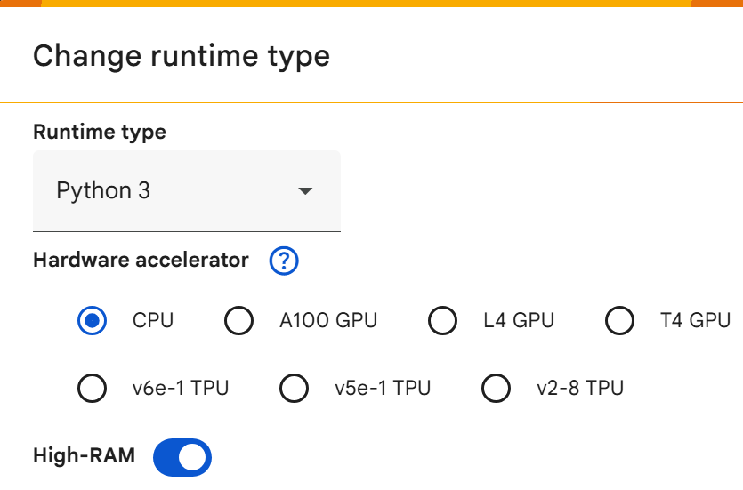
Figure 3.1. Google Colab “Change runtime type” menu.

3.4 Performance Parameters
The evaluation framework was tailored to the three research objectives of analysis - clustering, lead–lag detection, and forecasting - ensuring that each method was judged with metrics appropriate to its objectives.
- Clustering
Dendrograms from hierarchical clustering were first examined to visualise relationships between assets and highlight potential groupings. Cluster quality was then evaluated using the silhouette score, which measures cohesion within groups and separation between them.
- Lead–lag Analysis
Temporal dependencies between assets were evaluated through several complementary methods. Cross-correlation coefficients at multiple lags were used to detect whether movements in one series tended to precede another. Granger causality tests provided statistical evidence on whether past values of one asset contained predictive information about another, while Vector Autoregression (VAR) captured broader interdependencies among selected currencies.
- Forecasting Models
For predictive modelling, performance was assessed using both error- and direction-based metrics. Error measures included RMSE, MAE, and R², though the latter was interpreted cautiously due to the volatility of financial time series. Directional Accuracy (DirAcc) and ε-DirAcc were used to check whether models predicted the return direction correctly, and rolling-window evaluation tested the robustness of results over time.
- Comparisons
The forecasting stage incorporated benchmarks to contextualise the results. Baseline models included Persistence and Ridge regression, providing reference points for minimum expected performance. Traditional models such as ARIMAX were tested to capture autoregressive structures, while deep learning models in the form of LSTM networks - with exogenous leader inputs - were used to assess the potential of sequence learning in a volatile market environment.

3.5 Ethical Considerations
This research has relied exclusively on publicly available market data retrieved from Binance via its public API. No personal, sensitive, or proprietary user information has been collected, and therefore the privacy risk has been minimal. Use of the data has complied with the Binance API Key Terms and the site’s Terms of Use, which grant a personal, limited, non-exclusive, non-transferable licence for access and research purposes; unlike Creative Commons-licensed datasets, raw OHLCV files have not been redistributed (Binance, 2024). Only derived artefacts (figures, tables, trained weights) and the executable code have been shared.

Data security practices have been observed throughout. API credentials have been injected at runtime via Colab secrets/environment variables; no keys have been committed to the repository. Access has adhered to documented rate limits, and no scraping outside the published API has been performed.

Research integrity and reproducibility have been prioritised. Each stage of acquisition, preprocessing, modelling, and evaluation has been documented in an executable notebook, with versioned code archived in a GitHub repository. Known limitations such as survivorship and liquidity selection biases have been acknowledged in the scope, and results have been interpreted cautiously.

Given the domain, a dual-use risk has existed: predictive outputs could be misused for speculative trading by third parties. In line with prior ethics notes, this risk has been explicitly signposted; the study has been undertaken for academic purposes only and has not constituted financial advice. No live deployment, automated trading, or recommendation system has been implemented.

Institutional ethical approval has been granted for this work. Data handling and storage have complied with the terms of use of the data provider; no processing subject to data-protection legislation has arisen because no personal data have been involved.

Chapter 4: Design and Development

4.1 Overview
The design and development stage operationalises the CRISP-DM framework introduced earlier, moving from methodological principles to practical implementation. At this stage, the research methodology is translated into a concrete analytical pipeline that includes data acquisition, preprocessing, unsupervised clustering, lead–lag analysis, and predictive modelling.

The main aim is to transform abstract methodological steps into reproducible design choices that directly address the stated research objectives. These objectives provide the guiding structure for the workflow:
- Time-Series Clustering of Cryptocurrency Assets - realised through the design and implementation of Dynamic Time Warping (DTW) and related clustering techniques.
- Identification of Leading and Lagging Dynamics - examined through DTW alignment, where temporal offsets in pairwise distances reveal consistent leader-lagger relationships between assets.
- Predictive Modelling with Traditional and Deep Learning Methods - realised through applying statistical approaches (persistence, ridge regression, ARIMAX) alongside neural network approaches (LSTM).

Each stage of the pipeline is directly tied to the stated objectives, ensuring methodological coherence and enabling a rigorous evaluation of how design choices influence the final outcomes.

4.2 System Architecture
The system workflow was designed as a sequential pipeline that connects data acquisition with modelling and evaluation in a transparent and reproducible manner. At the highest level, the workflow begins with the download of cryptocurrency data from the Binance API, followed by exploratory data analysis (EDA) to gain an initial understanding of market dynamics and data quality. The overall process is illustrated in Figure 4.1.

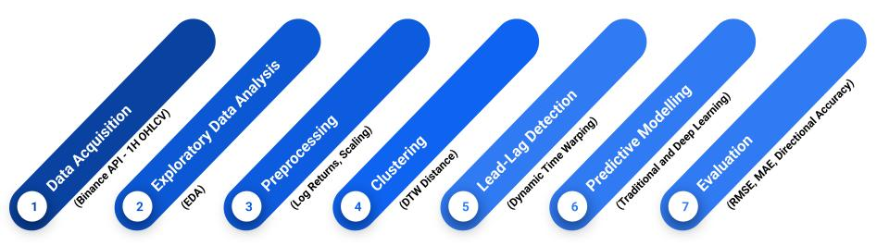
Figure 4.1. System Architecture Workflow for Cryptocurrency Clustering, Lead–lag Analysis and Forecasting.

Preprocessing forms the next stage, where the raw OHLCV data is transformed into log returns, aligned across assets, and scaled to ensure comparability (Fan & Yao, 2003). This step also includes handling of missing values and the generation of lagged features required for subsequent analyses.

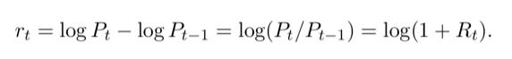
Figure 4.2. Log return formula (Source: Fan & Yao, 2003)

Once a consistent dataset is established, unsupervised clustering is applied using Dynamic Time Warping (DTW) distance to identify groups of assets with similar temporal behaviours. The resulting warping paths, as illustrated in Figure 4.3, show how DTW aligns two time series by stretching and compressing the time axis to minimise distance. Such alignments make it possible to detect systematic temporal offsets, which in turn provide insights into potential leading and lagging relationships among cryptocurrencies (Zhao & Itti, 2016).

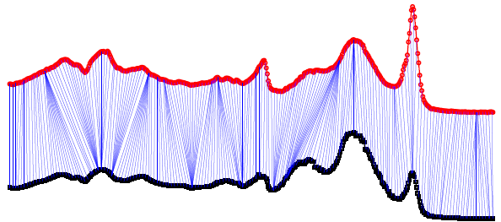
Figure 4.3. Example of Dynamic Time Warping alignment (Source: Zhao & Itti, 2016)

Building on these findings, predictive modelling integrates both traditional statistical methods (persistence, ARIMAX, ridge regression) and deep learning approaches (univariate and multivariate LSTM). These models are trained to forecast the movements of lagging assets, with leader assets incorporated as exogenous predictors where relevant.

The final stage of the architecture focuses on evaluation. Model outputs are assessed using a range of performance metrics, including RMSE, MAE, R², and directional accuracy, ensuring that both error magnitude and predictive directionality are considered.

This structured architecture provides a coherent link from data collection through to forecasting, with each stage designed to address one or more of the research objectives.

4.3 Architectural Choices
The implementation was carried out in Google Colab, a cloud-based Python environment that provides interactive notebook functionality alongside scalable computational resources. Colab was selected for its ease of use, built-in support for GPU acceleration, and seamless integration with Python libraries. Its notebook format enabled step-by-step execution, visualisation, and clear documentation, ensuring transparency and reproducibility of the entire pipeline.
The analytical workflow relied on several key Python libraries:
- NumPy and Pandas for efficient handling and transformation of OHLCV time-series data.
- Scikit-learn for clustering algorithms, dimensionality reduction, and evaluation metrics.
- TensorFlow/Keras for implementing and training LSTM neural networks, with GPU support for improved training efficiency.
- statsmodels for statistical modelling, including ARIMA/ARIMAX and Granger causality tests.
- SciPy and Matplotlib/Seaborn for DTW distance calculations, statistical analysis, and visualisation.

Running the workflow in Colab eliminated dependency issues and made it straightforward to reproduce results on different machines. Code, outputs, and figures were preserved in a single notebook, enabling full traceability of the design and development process.

4.4 Justification of Binance API, Data Storage Formats, and Reproducibility
The Binance API served as the data source because of its extensive market coverage, provision of OHLCV data at multiple granularities, and its status as one of the most liquid global exchanges. This flexibility in sampling frequency enabled the selection of intervals appropriate for both short-term lead–lag detection and longer-term forecasting experiments.

Raw data was initially stored in CSV format for inspection and archiving, while processed datasets were maintained in Pandas DataFrames for efficient in-memory computation during analysis.
Reproducibility was built into the workflow by using Colab’s versioned notebooks, fixing random seeds in algorithms where applicable, and documenting each transformation step in the pipeline. Ethical and regulatory compliance was maintained by adhering to the Binance API Terms of Use and ensuring that all retrieved data was used solely for academic purposes.

4.5 Data Design and Preprocessing

4.5.1 Data Collection - Secondary Data
The primary dataset consists of Open, High, Low, Close, and Volume (OHLCV) records obtained through the Binance API, which provides historical cryptocurrency market data at intervals ranging from one minute to one month. Following initial exploration in the notebook, a one-hour interval was adopted to reduce the excessive presence of near-zero returns observed at shorter frequencies (e.g., 15-minute), while still capturing sufficient temporal detail for lead–lag detection and forecasting. The research artifact, implemented in a Google Colab notebook, accessed the Binance API via a registered API key and secret, stored securely in the Colab secrets environment to protect credentials. Automated retrieval was carried out using Python’s python-binance library. Raw OHLCV data was initially stored in CSV format for inspection and reproducibility before being loaded into Pandas DataFrames for preprocessing and analysis.

The assets selected for analysis were major, liquid cryptocurrencies including Bitcoin (BTC), Ethereum (ETH), Binance Coin (BNB), XRP, Cardano (ADA), Solana (SOL), Dogecoin (DOGE), Polkadot (DOT), Litecoin (LTC), and others, reflecting both large-cap and actively traded altcoins. The rationale for this sampling was twofold:
- To ensure data quality by focusing on assets with high trading volume and liquidity, thereby reducing noise and artificial sparsity.
- To provide diversity across categories of cryptocurrencies, allowing clustering methods to uncover both dominant market leaders and secondary assets with lagging dynamics.

The dataset spans a continuous 13-month period, ensuring that patterns are not biased by short-term anomalies.

4.5.2 Data Cleaning
To ensure the reliability of the dataset, several cleaning checks were carried out before analysis. A missing value audit was performed using the missingno library, which confirmed that the dataset contained no null entries across the selected features (Figure 4.4).
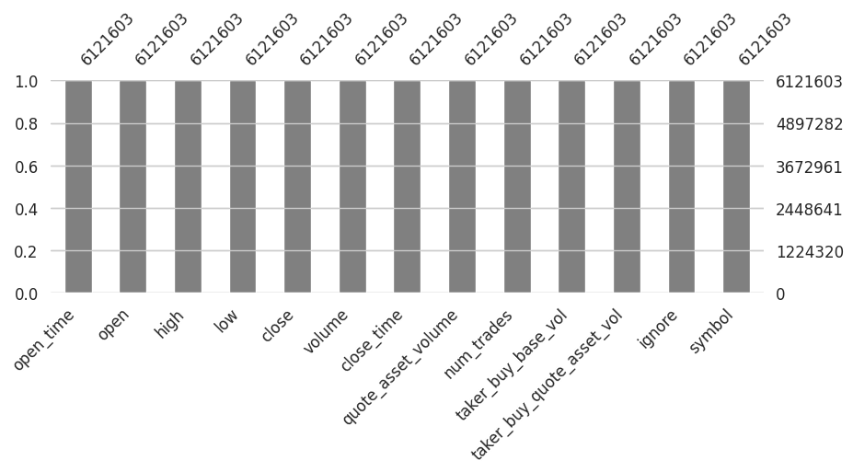
Figure 4.4 Missing value audit confirming that no null entries were present.

In addition to completeness at the row level, a validation step was implemented to confirm that each cryptocurrency maintained continuous coverage across the full expected time window from 1 July 2024 to 1 August 2025. Assets with truncated histories, such as late starts or early terminations in their time series, were identified by comparing the earliest and latest timestamps for each symbol. A number of assets - primarily low-cap tokens with sporadic trading - failed this criterion and were excluded from further analysis. By filtering these out, the dataset retained 143 cryptocurrencies with uninterrupted coverage across the study period.

During preliminary testing, shorter sampling intervals (15 and 30 minutes) produced a high proportion of zero and near-zero returns, reducing the effective retention of assets for analysis. In contrast, the one-hour interval retained the full asset set without excessive sparsity, providing a more reliable basis for clustering and forecasting (Figure 4.5).

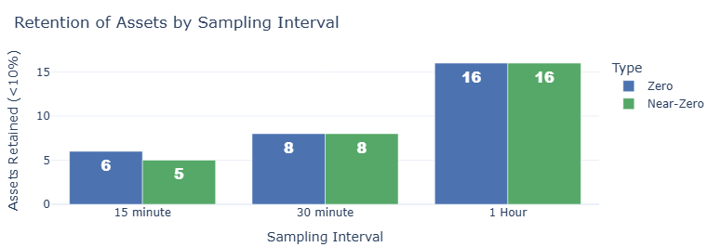
Figure 4.5 Retention of Assets by Sampling Interval, showing the number of assets with excessive zero and near-zero returns at different intervals.

The time indices of all assets were aligned to a uniform one-hour grid, ensuring that clustering and lead–lag detection were based on synchronised time series. No duplicate entries were identified in the dataset, which simplified the cleaning process.

4.5.3 Feature Engineering - Primary Data
Calculation and Integration of Log Returns
To prepare the dataset for time-series clustering and forecasting, log returns were calculated for each cryptocurrency’s closing price. Logarithmic returns are preferred over simple percentage changes as they are time-additive and better suited for modelling financial time series. The calculation was performed by grouping the data by symbol and applying the natural log of the price ratio between consecutive timestamps. Inspection of the first rows confirmed that the additional column was correctly aligned: small numerical values reflected minimal price changes between consecutive timestamps, while zero values occurred when the closing price remained unchanged between two consecutive periods. An example is shown in Figure 4.6, where the second row displays a log return of zero due to identical closing prices across consecutive timestamps.

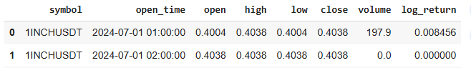
Figure 4.6 Example of log return calculation, showing both a small positive return and a zero return when consecutive closing prices remain unchanged.

Cleaning Merge Artifacts
The merge process generated duplicated symbol columns (symbol_x and symbol_y). These were redundant and removed for clarity, with the symbol field retained under a single consistent column name. This step simplified the dataset and avoided potential confusion in downstream analyses.

Reordering Columns for Readability
For better readability and logical ordering, the symbol column was repositioned to appear immediately after the open_time field. This reorganisation improved interpretability during exploratory analysis and ensured a consistent schema for subsequent modelling tasks.

Selection of Relevant Features
To reduce memory usage and improve computational efficiency, only the essential fields were retained for downstream analysis.
The final feature set included:
- Timestamps (open_time)
- Asset identifier (symbol)
- OHLC prices (open, high, low, close)
- Trading volume (volume)
- Log returns (log_return)

This filtered dataset formed the primary data structure for all subsequent tasks, including stationarity testing, DTW clustering, lead–lag identification, and LSTM forecasting.

4.6 Exploratory Data Analysis after Data Preparation

4.6.1 Initial correlation scan
To probe potential lead–lag structure, Pearson correlations were calculated between the hourly return series of the reference asset (BTCUSDT) and each other cryptocurrency across a symmetric lag window of -10 to +10 hours. The analysis revealed moderate to strong associations, with coefficients ranging from 0.49 to 0.77. For most assets, the peak correlation occurred at lag 0, suggesting that returns move largely contemporaneously.

4.6.2 All-pairs cross-correlation
To avoid implicit leader bias from using BTC as the sole anchor, the procedure has been extended to every ordered pair of assets. For each (A, B), the algorithm has searched lags [−10,+10] to identify the maximum ∣r∣, recording leader = A, follower = B, best_lag, and the associated correlation. Sorting by abs_corr has provided a ranked view of the strongest relations together with the lag at which they have occurred. This has produced a comprehensive map of synchronous and shifted co-movements across the asset universe, revealing generally strong correlations, with most best_lag values remaining at zero.

4.6.3 Correlation matrix on log returns
Leader-follower pairs have been pivoted into a square matrix with a common symbol order for rows and columns. The red–blue diverging palette revealed broad positive dependence across assets, consistent with a market that tends to move in tandem (Figure 4.7).

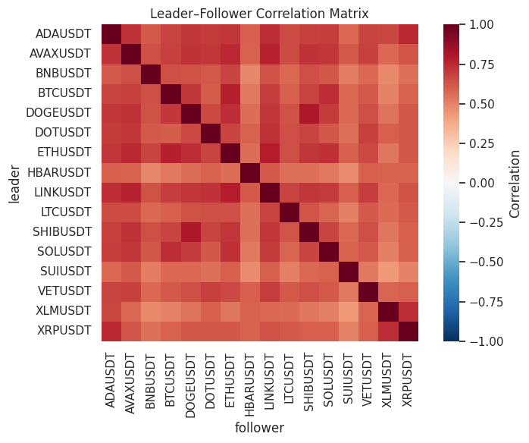
Figure 4.7 Correlation matrix based on return series.

Correlation observation
The strongest pairs - for example, SHIBUSDT-DOGEUSDT (|r| ≈ 0.81) - have peaked at lag 0, indicating near-simultaneous responses to common shocks rather than a stable temporal precedence. Such zero-lag strength has been informative about overall market cohesion but has not, by itself, been exploitable for forecasting.

4.6.4 Filtering Candidate Lead–Lag Relations
Since prediction requires temporal precedence, the analysis has filtered to positive-lag peaks (best_lag > 0). No asset pairs have satisfied this criterion, indicating that, under this method, no cryptocurrency has consistently led another.

4.6.5 Granger causality and VAR validation
Stationarity testing
Granger causality analysis requires weak stationarity. Augmented Dickey-Fuller tests have been applied to the hourly log-return series for each asset in the top candidate pairs. All series have rejected the unit-root null at conventional levels (p < 0.01), thereby satisfying the precondition for valid causality inference.

Pairwise Granger Causality (Leader → Follower)
Bivariate Granger tests have been conducted for each candidate pair over lags 1-10 to assess whether past returns of the assumed leader improve the prediction of the follower. Results have been reported as F-tests with associated p-values by lag. For instance, SHIBUSDT → DOGEUSDT has shown strong significance at lag 1 with a gradual decay across longer horizons, suggesting short-term predictive content.

Directional Consistency and Reverse Tests
To mitigate spurious directionality, reverse specifications (follower → leader) have also been tested. The first five high-correlation pairs - such as SHIB-DOGE, LINK-ETH, BTC-ETH, AVAX-LINK and AVAX-ETH - have exhibited bidirectional significance consistent with feedback loops and common shocks, limiting their suitability as stable leader-follower structures.

Identification of Unidirectional Leaders
Pairs that have remained significant in one direction but non-significant (or materially weaker) in the reverse direction have been flagged as clearer leadership candidates. In this dataset, LINK → AVAX and ETH → AVAX have stood out: LINK and ETH have exhibited durable, statistically robust predictive content for AVAX, whereas feedback from AVAX has been weak or has disappeared under multiplicity control.

Multivariate confirmation with VAR
Vector Autoregression (VAR) models have been fitted for the two shortlisted pairs, with lag order determined by the Akaike Information Criterion (AIC) and cross-checked against the Bayesian Information Criterion (BIC). Granger non-causality tests within the VAR framework have confirmed the pairwise findings:
- LINK → AVAX: F-test p ≈ 5.9×10⁻¹¹; reverse direction not significant (p ≈ 0.188).
- ETH → AVAX: F-test p ≈ 8.7×10⁻⁷; reverse direction not significant (p ≈ 0.184).

These results have strengthened the evidence for a unidirectional information flow from LINK and ETH toward AVAX at the hourly horizon.

4.6.6 Normalisation before DTW
Rationale
Correlation, Granger causality, and VAR rely on fixed linear timing and assume constant propagation speeds. In contrast, spillovers in cryptocurrency markets can be episodic and nonlinear, with reaction lags that expand or contract over time. Dynamic Time Warping (DTW) addresses this by aligning two series under local time distortions, returning both a distance measure and an alignment path. This has enabled verification that the LINK → AVAX and ETH → AVAX relations persist even when relative timing temporarily drifts.
Scale Diagnostics
Prior to distance-based analysis, scale diagnostics have been conducted on the return series, examining means, standard deviations, ranges, and the presence of negative values. The diagnostics have indicated that log returns exhibit substantial variability in dispersion, with a max-min standard deviation ratio of 2.61 and a range ratio of 4.28. Without scaling, assets with higher volatility would disproportionately influence similarity measures, biasing the results.
Visual checks
As preliminary validation, two visual checks have complemented the diagnostics. Figure 4.8 presents bar plots of the zero-share by asset, highlighting HBAR with most sparse movement through the fraction of exact zero hourly returns and ETH and BTC with least.
Figure 4.9 shows return histograms for individual assets, confirming the presence of heavy tails and heterogeneous dispersion across the universe.
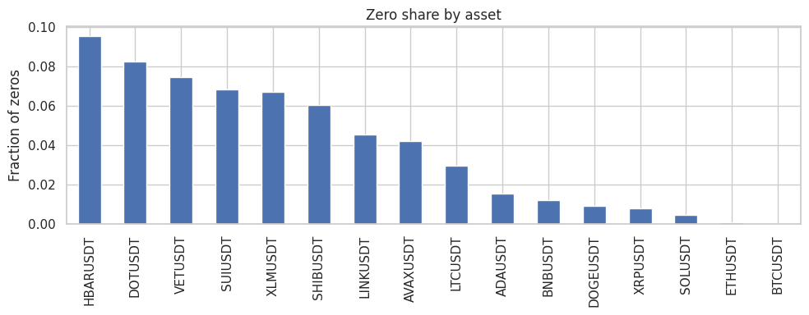
Figure 4.8. Zero-share by asset.
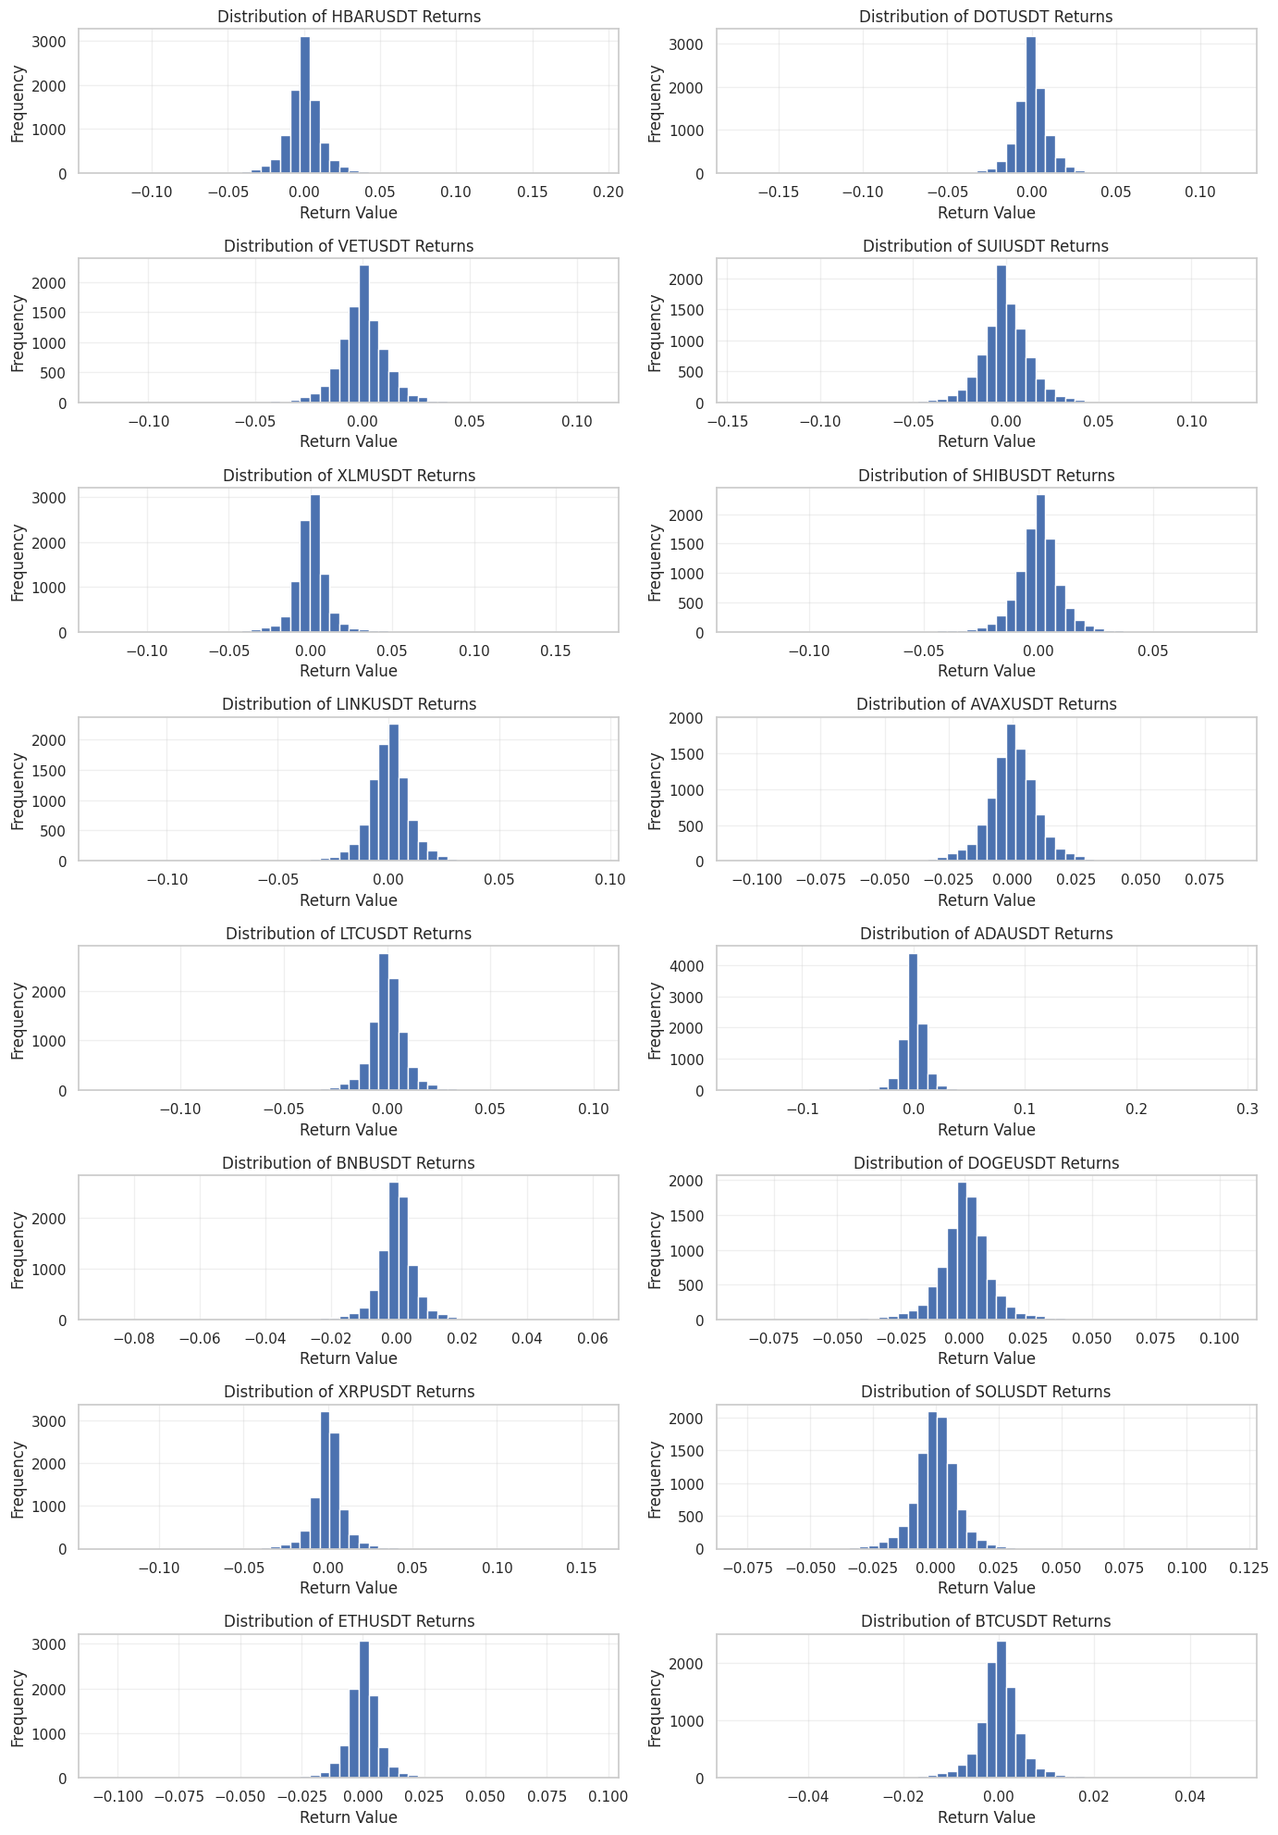
Figure 4.9. Return histograms by asset.

4.6.7 Justification for Robust Scaler
Taken together, the diagnostics and visual checks - along with evidence of heavy-tailed returns, heterogeneity in dispersion, and sparse movement in some assets - have motivated the application of robust normalisation to ensure comparability across series in distance-based analyses.

4.7 Data Preparation for Clustering

4.7.1 Outliers Winsorisation
Outlier diagnostics using a two-sided 0.1% / 99.9% percentile rule have flagged around 20 observations per asset out of 9,504 (0.210%), as expected by construction. The variation in cut-off values across assets (e.g., BTCUSDT [−0.0297, 0.0294] versus HBARUSDT [−0.0654, 0.0934]) has indicated heavier and sometimes asymmetric tails for several altcoins. To mitigate the influence of such extremes while retaining asset-specific dynamics, each series has been winsorised at these quantile thresholds, providing stable inputs for subsequent scaling and modelling (Abuzaid and Eyad Alkronz, 2024).

4.7.2 Outlier-Resilient Normalisation via Robust Scaling
The return series have displayed zero-inflation (≈2–10% zeros for several assets), heavy tails, and occasional extremes - conditions under which mean/variance standardisation has been disproportionately influenced by outliers. Robust scaling has therefore been applied, centring each series by its median and scaling by its interquartile range, consistent with robust-statistics practice (Huber and Ronchetti, 2009) and as operationalised in scikit-learn’s RobustScaler (Pedregosa et al., 2011). This procedure, implemented after winsorisation, has preserved both time ordering and cross-asset comparability, yielding stable inputs for Dynamic Time Warping.

After winsorisation and robust scaling (Figure 4.10), the return distributions have become more homogeneous across assets, with extreme tails compressed and scales aligned, in contrast to the pre-scaling histograms (Figure 4.9) where dispersion and asymmetry varied widely.

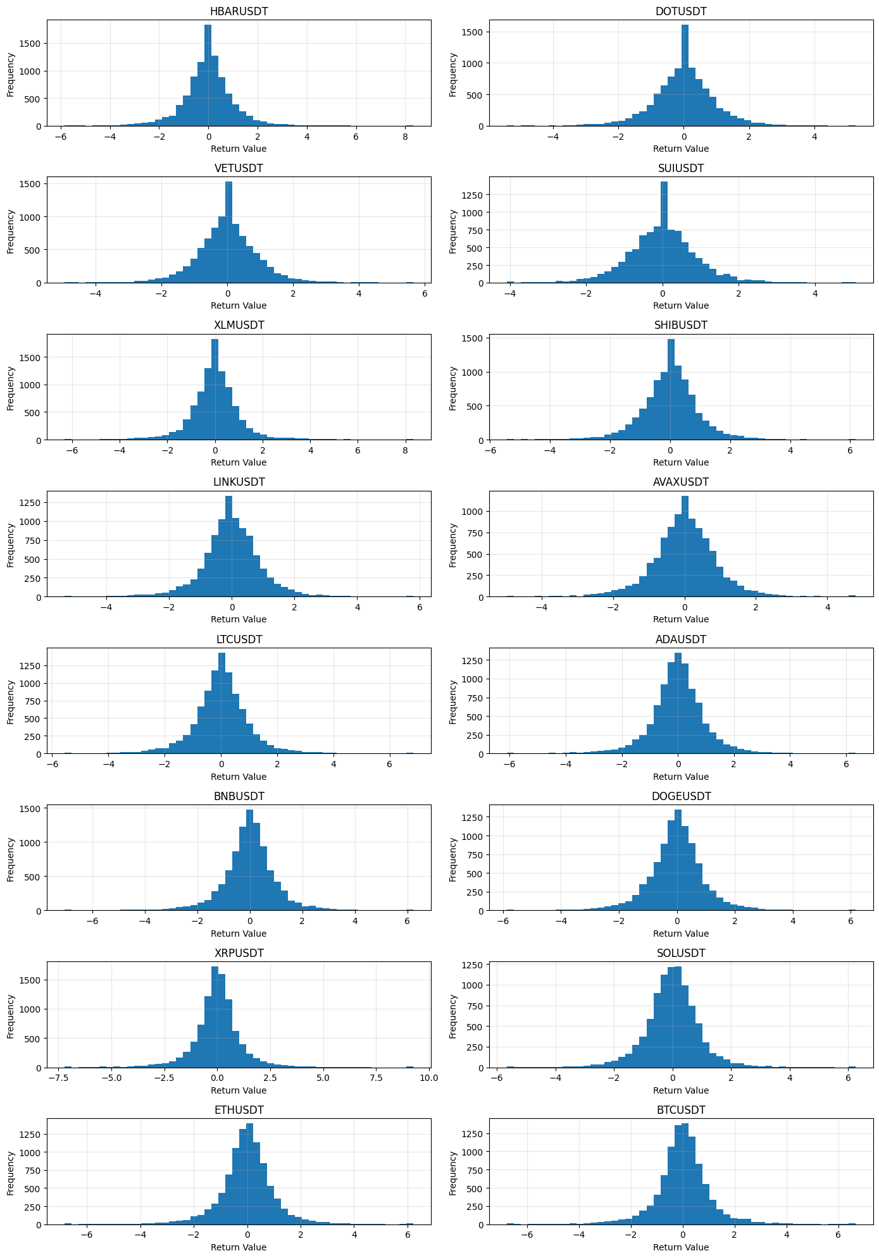
Figure 4.10. Distribution of returns after winsorisation and robust scaling.

4.8 DTW Clustering of Hourly Returns
The scaled and winsorised returns have been organised into a panel with assets treated as multivariate observations to enable DTW-based comparison. Pairwise DTW distances have been computed with a Sakoe–Chiba band of ±10%, which constrains the alignment path to allow for short-lived timing distortions while preventing unrealistic long-range warping. The resulting symmetric distance matrix has then been subjected to hierarchical clustering, with the tree structure visualised through a dendrogram. Cluster quality has been evaluated using internal validation indices, including the cophenetic correlation coefficient and silhouette scores across different values of k. These measures have provided a systematic framework for assessing cohesion within clusters and separation between them.

4.9 DTW-Based Lead–Lag Analysis
Building on the clustering results, the next stage of the analysis has focused on examining potential lead–lag relationships among the assets. This step has aimed to determine whether certain cryptocurrencies have systematically preceded others in their temporal dynamics, thereby revealing internal leadership patterns within the dataset.

4.9.1 Preparation of Return Series for Lead–Lag Detection
Although stationarity had already been established at the log-return stage, ADF tests were reapplied to the winsorised and scaled returns to confirm that preprocessing had not altered this property. All sixteen series again rejected the unit-root null (p < 0.01), validating their suitability for subsequent DTW and Granger analyses.

4.9.2 Pairwise DTW-Based Lag Estimation
Pairwise DTW has been applied to all return series to quantify both temporal dissimilarity and relative precedence. While DTW distance has measured overall shape similarity, the mean offset along the optimal warping path has provided an estimate of whether one asset has systematically led another. The resulting lag matrix (Figure 4.11) has captured directional tendencies, with positive values indicating leader behaviour. For example, BTC→BNB = +8.6 has suggested that BTC return dynamics have typically preceded those of BNB by approximately eight to nine hours.
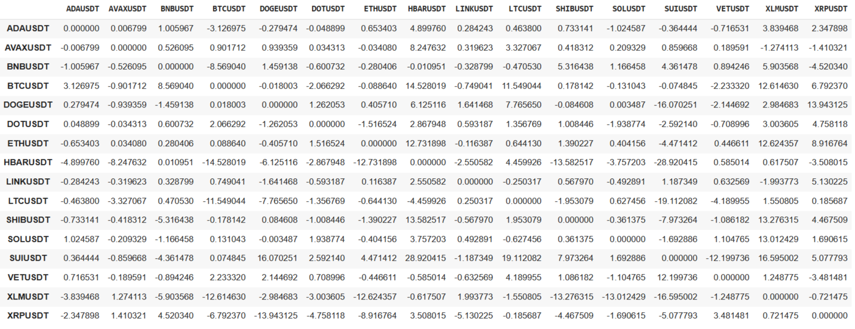
Figure 4.11. Head of the DTW pairwise lag matrix.

4.9.3 Leader-Lag Score Computation
Because the data have been sampled hourly, sub-hour offsets have been recorded as synchrony, ensuring only meaningful lags (≥ 1 hour) have been retained. For each asset, a net leader score has been computed as the sum of its effective pairwise lags (Figure 4.12), with positive values indicating consistent precedence and negative values indicating follower behaviour. The ranking has highlighted SUIUSDT, BTCUSDT, and ETHUSDT as dominant leaders, while HBARUSDT, XLMUSDT, and LTCUSDT have emerged as consistent laggards.
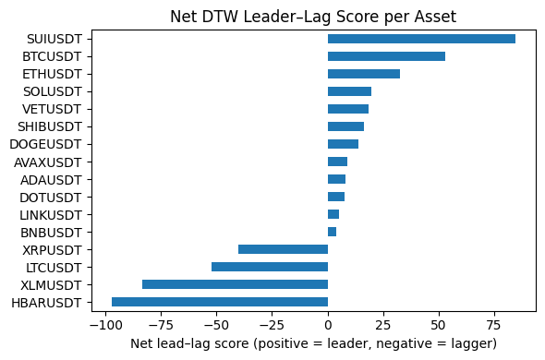
Figure 4.12. Bar Chart Visualisation of Net DTW Leader-Lag Scores

4.9.4 Validation with Granger Causality
To validate these DTW-derived relationships, Granger causality tests have been applied to the strongest contrasts, comparing the top three leaders with the bottom three laggards. Results have confirmed that BTCUSDT and SUIUSDT have consistently predicted movements in HBARUSDT, LTCUSDT, and XLMUSDT at a one-hour lag (p < 0.01), while ETHUSDT has displayed weaker and less consistent leadership.

4.9.5 DTW Lead–Lag Conclusion
The combined DTW and Granger analyses have established BTCUSDT and SUIUSDT as strong leaders, with HBARUSDT, XLMUSDT, and LTCUSDT emerging as clear laggards. These findings have validated the DTW-based ranking and have provided a reliable set of leader-follower pairs for subsequent modelling.

4.10 Forecasting with Traditional Time-Series Models

4.10.1 Persistance
HBARUSDT has been selected as the forecasting target and SUIUSDT as the candidate leader for short-horizon prediction. The lead–lag horizon ℎ has been estimated by scanning correlations, and this horizon has defined the one-step-ahead task. A supervised dataset has then aligned SUI with HBAR{t+h}, dropping lag-induced rows to avoid leakage. Two baselines have been defined: Persist-Target (HBAR → HBAR{t+h}) and Persist-Leader (SUI → HBAR{t+h}).

4.10.2 Ridge Regression - Single-Leader
Ridge regression has been configured in a single-leader setting, with HBARUSDT as the target and SUIUSDT as the leader. A supervised frame has been constructed by aligning SUI𝑡 and HBAR𝑡 as predictors of HBAR𝑡+ℎ. Within the training window, the regularisation strength 𝛼 has been selected via RidgeCV, providing L2 shrinkage to stabilise coefficients and mitigate multicollinearity.

4.10.3 Ridge Regression - Multi-Leader
A multi-leader specification has been set with SUIUSDT, SOLUSDT, and ADAUSDT. Per-asset offsets have been estimated and a common one-step horizon (h = 1) has been adopted to favour immediate signals and reduce noise accumulation. The supervised frame has aligned each leader at time t (shifted by its estimated lead relative to h) to predict HBARt+h, with lag-induced rows removed. Features have been sourced from the pre-scaled panel (scaled_returns); because scaling has preceded splitting, a minor leakage risk has been acknowledged, and subsequent deep-learning experiments have fitted the scaler on training data only.

4.10.4 Common Protocols applied for Persistence and Ridge
Lead–lag relationships have been estimated by scanning correlations over 1-60 steps to set ℎ and any per-asset shifts; data have then been partitioned chronologically (80/20) to preserve temporal order. Evaluation has been pre-specified as RMSE, MAE, 𝑅2, and directional accuracy on the held-out window, and a standard actual - predicted plot with residuals has been prepared for each specification. Where features have come from a pre-scaled panel, the minor leakage risk has been acknowledged; for learning models later in the pipeline, scalers have been fitted on the training window only.

4.10.5 ARIMAX With All DTW Leaders
ARIMAX has been configured to couple the autoregressive structure of HBARUSDT with exogenous leader signals derived from DTW lead–lag analysis. The target has remained HBARUSDT returns, and a broad leader set (including assets with positive and negative DTW scores) has been assembled. Model order has been selected via a compact AIC-based grid search using SARIMAX with the seasonal component disabled, and the specification with the lowest AIC has been retained for forecast generation.

4.10.6 ARIMAX With Positive DTW Leaders Only
ARIMAX has been configured with exogenous predictors restricted to assets with positive Net DTW scores, aiming to exclude inverse or weak relationships and to focus on leaders exhibiting consistent short-horizon precedence. The fitted model has then generated out-of-sample forecasts using the test exogenous series.

4.10.7 Common protocol for ARIMAX models
Across both designs, per-leader lead–lag offsets have been estimated by scanning correlations over lags 1-30, after which a one-step horizon (h = 1) has been adopted to prioritise short-horizon signal and limit column loss from shifting. Exogenous matrices have been constructed by shifting each leader by its estimated lead relative to ℎ and aligning them with HBARt+h, with lag-induced rows dropped to prevent leakage. As likelihood-based ARIMAX operates on raw returns, no additional feature scaling has been required. The supervised panels have been split chronologically (80/20) to preserve temporal order, and model order has been determined via non-seasonal SARIMAX with an AIC-based grid. Evaluation has been pre-specified as RMSE, MAE, R2, and directional accuracy on the held-out window, with a standard actual-predicted plot and residual panel prepared for like-for-like comparison with other model families.

4.11 Forecasting with Deep Learning Models (LSTM)
While Ridge regression and ARIMAX models have provided valuable benchmarks, their predictive power has been limited in the presence of non-linear dependencies and heavy-tailed return distributions. To address these limitations, Long Short-Term Memory (LSTM) networks have been introduced as a deep learning architecture designed to capture sequential dependencies. LSTMs are particularly well suited to one-step-ahead financial forecasting because they retain information across multiple time steps and can model complex temporal patterns that are not well captured by linear methods.

4.11.1 LSTM Data Preparation and Exploratory Analysis
The preparation of data for LSTM modelling has required a sequence of structured transformations designed to preserve temporal integrity while mitigating the effects of noise, missing values, and extreme observations. Given that LSTMs rely on sequential inputs, particular care has been taken to align lagged leader features with the target variable, avoiding look-ahead bias and ensuring that only information available at time t-L has been used to predict the target at time t.

4.11.1.1 LSTM Target and Leader Asset Definition
HBARUSDT has remained the forecasting target due to its consistent presence as a lagging asset in the DTW and Granger causality analyses. Leader inputs have been drawn from the set of strongest positively scoring assets identified earlier, specifically SUIUSDT, SOLUSDT, ADAUSDT, BTCUSDT, and ETHUSDT. These have been extracted into a leader feature matrix to form the explanatory variables.

4.11.1.2 Forecast Horizons and Construction of Lagged Features
For each leader, the optimal lag has been identified through correlation scanning across horizons of up to 30 time steps. This has balanced the need to capture genuine temporal precedence against the risk of excessive column loss due to shifting.
The target series has been augmented with lagged leader features using the best-lag mapping, generating a supervised dataset in which predictors at time t-L are paired with the target at time t. By discarding rows with missing values arising from lagging, the final dataset has ensured valid alignment for LSTM sequence generation.

4.11.1.3 Chronological Splitting and Target–Feature Separation
To preserve the time-ordering inherent in financial series, the dataset has been divided chronologically into 70% training, 15% validation, and 15% testing subsets. This allocation has maximised the amount of data available for fitting the LSTM while retaining sufficient unseen data for hyperparameter tuning and unbiased performance evaluation. A systematic audit has confirmed that no missing values remained after preprocessing.

For each split, the target variable has been separated from the leader feature matrix.
Exploratory histograms of the target and leader returns have confirmed distributions centred close to zero with heavy tails and occasional extreme values. These characteristics have highlighted the volatility typical of cryptocurrency returns and justified the use of robust preprocessing techniques (Figure 4.13).

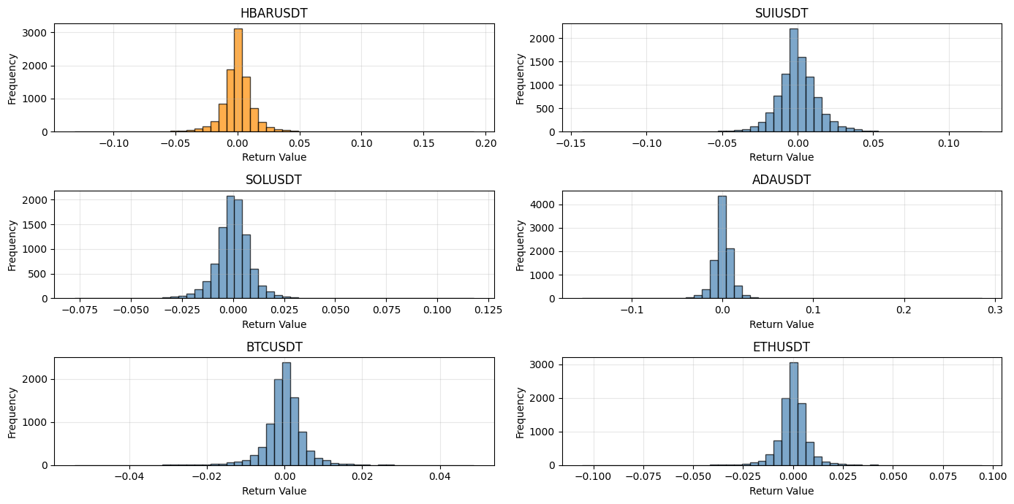
Figure 4.13. Histograms of log returns for the target (HBARUSDT, orange) and selected leader assets (blue).

Boxplots have complemented the histograms by emphasising dispersion and the presence of outliers. Consistent colour-coding (orange for the target, blue for leaders) has been kept for interpretability across figures. Outliers have been identified as hollow circles, confirming that several assets exhibit pronounced extremes in their return distributions (Figure 4.14).

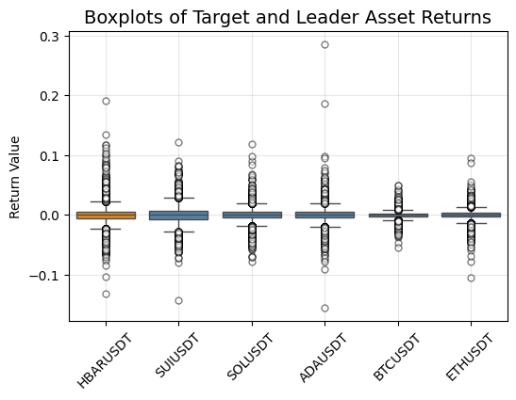
Figure 4.14. Boxplots of log returns

Final shape checks have verified the dimensions of the training, validation, and test sets across both targets and features, confirming that the preprocessing pipeline has preserved sufficient observations for sequence-based modelling.

4.11.1.4 Normalisation - Robust Scaler
Leader features have been scaled using RobustScaler, fitted exclusively on the training set to prevent leakage. By centring values at the median and scaling by the interquartile range, this approach has reduced the undue influence of extreme returns while preserving the distributional characteristics required for modelling.
Boxplots comparing returns before and after scaling (Figure 4.15) have shown that although heavy tails remain, the scale has been normalised across assets.
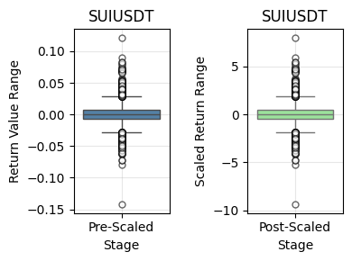
Figure 4.15. Pre-scaled and post-scaled boxplots of SUIUSDT.

Checks have confirmed alignment between feature indices and target indices across all dataset splits, safeguarding against misalignment during supervised sequence construction.

4.11.1.5 Dimensionality Reduction - Principal Component Analysis (PCA)
To address multicollinearity among the leader assets and compress redundant information, PCA has been applied to the scaled feature panel. PCA has produced independent (uncorrelated) components that have captured maximal variance subject to zero-correlation constraints, computed via singular value decomposition (SVD) (Jolliffe, 2002). The transformation has been fitted on the training folds only, and the learned loadings have then been applied to the validation/test sets to avoid information leakage. Prior to PCA, features have been centred and scaled (per Section 4.x), ensuring that components have reflected correlation structure rather than scale artefacts (Jolliffe and Cadima, 2016).

A fixed variance–explained rule has been used, retaining the smallest k such that cumulative explained variance ≥ 95%. This has reduced dimensionality while preserving the dominant covariance structure across assets and has improved conditioning for downstream sequence models by mitigating collinearity and noise (Bishop, 2006). A scree plot of cumulative explained variance (Figure 4.16) has illustrated the elbow and confirmed the adequacy of the chosen k.
The retained components have been used as exogenous inputs alongside the target’s own history. By concentrating information into a lower-dimensional, uncorrelated basis, the LSTM has been allowed to focus on the most informative signals and has reduced the risk of overfitting relative to using many highly correlated raw assets.

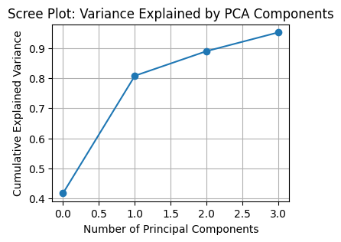
Figure 4.16. Scree plot showing cumulative variance.

4.11.1.6 Exploratory Summary
The exploratory analysis has revealed that cryptocurrency returns cluster around zero but display pronounced heavy tails and recurring outliers. Applying the RobustScaler has helped to temper the influence of these extremes, while PCA has reduced redundancy by capturing the strongest shared variance across assets. Together, these steps have produced a cleaner and more coherent feature space that respects temporal ordering and is well-suited for constructing sequences for LSTM forecasting. As the next step, multivariate LSTMs are applied to test whether leader-lagger dynamics can improve predictive performance beyond the linear benchmarks.

4.11.2 LSTM Sequence Construction
The first step has been to transform the feature matrix and target series into supervised learning sequences. Rolling windows of a fixed lookback length have been applied (lookback of 192 hours - equivalent to eight days), with each sequence of past observations predicting the return at the next time step. This baseline has balanced the need to capture medium-term dependencies against the risk of losing too many observations.

4.11.3 LSTM Model Construction and Training
The LSTM model has been implemented using TensorFlow/Keras with configurable hyperparameters including the number of units, layers, dropout rate, and learning rate. In the baseline configuration, a single LSTM layer with 32 units and a dropout rate of 0.2 has been used, followed by a Dense output layer generating one-step return predictions. Training has been optimised with the Adam algorithm and mean squared error (MSE) loss, with gradient clipping applied for stability. Early stopping and learning-rate reduction callbacks have been employed to prevent overfitting and accelerate convergence. The model has been trained for up to 40 epochs with a batch size of 64, using the validation set for monitoring progress. Sequence inputs have been constructed from lookback windows, with horizon h=1, ensuring that only information available up to t-1 has informed the forecast at t.

4.11.4 Hyperparameter Tuning Strategy
Rationale and approach.
To control computational cost while exploring a high-dimensional space, tuning has proceeded in two stages: an initial random search to locate promising regions, followed by a focused grid search over the best-indicated ranges. Early stopping and adaptive learning-rate reduction have been enabled throughout to curb unnecessary epochs.

4.11.4.1 Stage 1 - Random search (coarse exploration).
Random search has sampled combinations of the main drivers of capacity and temporal context - lookback (LB), units, layers, dropout, learning rate, and batch size - while keeping the architecture and loss fixed (LSTM→Dense with MSE, Adam). Validation RMSE has been used as the selection criterion, with MAE and DirAcc monitored as secondary diagnostics.
This stage has pointed to:
- Medium windows with lookback 280
- Units: 128
- Layers: 2
- Dropout: 0.0
- Learning Rate: 5e-4
- Batch: 64

4.11.4.2 Stage 2 - Grid search (local refinement).
A compact grid centred on the random-search peaks has then been evaluated:
- LB ∈ {300, 320, 400, 500}
- units ∈ {128, 256}
- layers ∈ {2, 3}
- dropout fixed at 0.3 (based on random search stability)
- learning rate fixed at 1e-2, 1e-3, 5e-4, 1e-4
- batch size ∈ {16}

Even on a high-spec Colab A100 machine with GPU, the full grid has taken ~8 hours due to the sequence length (LB), stacked layers, and the number of training iterations per setting.

The resulting development configuration selected for subsequent evaluation has been: LB = 320, units = 256, layers = 2, dropout = 0.3, LR = 1e-4, batch = 16, epochs = 30;. A brief sensitivity check has then confirmed that larger batches can modestly change optimisation behaviour, while longer lookbacks or deeper stacks have increased compute without clear validation gains; very small learning rates have slowed convergence without improving validation loss.

4.11.5 LSTM: Rolling-Window Evaluation
A rolling-window strategy has been adopted to assess robustness across changing market conditions. The full, chronologically ordered PCA feature panel has been partitioned into successive folds, each with a training window = 30% of the timeline and a test window = 7%, advanced by one test window per step. Within each training window, 7% has been held out for validation. For every fold, sequences have been created with h = 1 and the specified lookback (LB), an LSTM has been trained with early stopping and learning-rate reduction, and predictions have been generated on the subsequent test window. Metrics (RMSE, MAE, R², DirAcc) have been recorded per fold, and the final fold has been retained for visual inspection.
Configuration.
The initial evaluation has used LB = 240, units = 128, layers = 2, dropout = 0.3, LR = 1×10⁻⁴, batch = 32, epochs = 30. All splits have preserved temporal order, and sequence construction has ensured that only information available at time t−LB…t−1 has informed the forecast at t, preventing look-ahead bias. A schematic of the multivariate LSTM forecasting architecture, showing the stacked layers and output design, is presented in Figure 4.17.

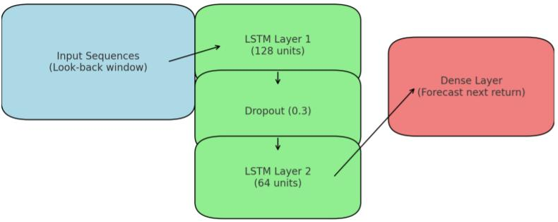
Figure 4.17. Multivariate LSTM forecasting architecture.

4.12 Workflow Checkpointing and Computational Strategy
A checkpointing strategy had been adopted to improve efficiency and reproducibility. At key stages of preprocessing and transformation, intermediate DataFrames had been saved to Google Drive, allowing the analysis to resume from different points without re-running the entire notebook. This had reduced computational overhead and supported validation of specific steps. For computationally intensive tasks, the Colab environment had been switched to a higher-powered machine, allowing DTW calculations and neural network training to be completed within reasonable time. This strategy had been chosen to balance reproducibility, efficiency, and practical resource management in a cloud-based environment.

4.13 Design and Development Summary
This chapter has operationalised the methodology into a reproducible pipeline. It has specified data preparation (winsorisation where appropriate, RobustScaler, and PCA), leader-feature construction from DTW alignment and Granger tests with lag mapping, chronology-preserving splits, and supervised sequence design for modelling. It has defined the model set (persistence, Ridge, ARIMAX, and multivariate LSTM) and the tuning protocol that has combined an initial random search with a focused grid to control compute. The evaluation procedure has been established through a fixed chronological split and a rolling-window scheme, with RMSE, MAE, R², and directional accuracy set as reporting metrics.
With the design finalised, the framework has been ready for empirical assessment.

Chapter 5: Results and Conclusion

5.1 Guiding Questions and Objectives
This study has been guided by three central research questions and objectives. The first has asked whether clustering based on Dynamic Time Warping (DTW) can reveal meaningful groupings of cryptocurrencies with similar return behaviours. The second has examined whether cryptocurrencies show consistent leader-follower dynamics and how stable such effects are across assets and time horizons. The third has evaluated whether predictive models, including traditional and neural network approaches enhanced with leader inputs, can achieve improvements over simpler baselines in forecasting returns.

Accordingly, the objectives have been: (1) to apply unsupervised learning with DTW to group cryptocurrencies, assessed with internal validation indices; (2) to investigate temporal dependencies through cross-correlation, Granger causality, and VAR to evaluate lead–lag effects; and (3) to develop and test forecasting models, comparing baselines (Persistence, Ridge, ARIMAX) with LSTM networks using RMSE, MAE, and directional accuracy.

5.2 Results

5.2.1 Clustering of Cryptocurrency Assets
The first research objective has focused on grouping cryptocurrencies according to similarities in their temporal behaviour. Dynamic Time Warping (DTW) distance was used to measure pairwise similarity across hourly log-return series. The reordered heatmap (Figure 5.1) has provided an overview of pairwise distances, showing that most assets exhibited broadly similar behaviour, with no sharply defined block structures emerging.

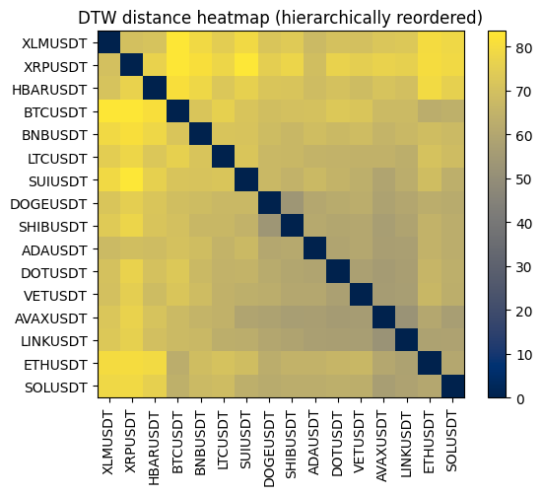
Figure 5.1. DTW distance heatmap (hierarchically reordered) of 16 cryptocurrency assets.

To complement this, a hierarchical clustering dendrogram was produced (Figure 5.2). The dendrogram has confirmed that while assets could be cut into three groups at a distance threshold of h=73.354, the separations were weak. The silhouette score for k=3 was 0.121, with the maximum across k=2-8 reaching only 0.133, confirming weak cluster separability.

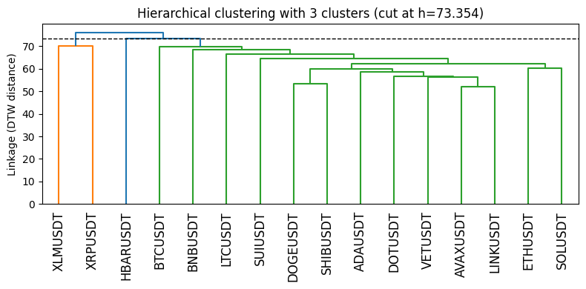
Figure 5.2. Hierarchical clustering dendrogram cut at h=73.354.

These results have indicated that the selected assets behaved as a single broad market cluster, characterised by strong synchronous movement rather than distinct subgroups. This finding aligns with previous observations that cryptocurrency markets are highly cohesive and often move together under common shocks (Sigaki et al., 2019). Consequently, the 16 assets have not been divided into smaller clusters but are instead considered together in the next stage of the analysis, where potential leader–follower relationships are examined.

5.2.2 Lead–Lag Dynamics
The second objective has examined whether certain cryptocurrencies systematically precede others. Initial cross-correlation analysis has confirmed moderate to strong associations across assets, with peak coefficients ranging from 0.49 to 0.77. However, the vast majority of pairs peaked at lag 0, indicating contemporaneous behaviour rather than predictive precedence.
The Granger causality results have revealed bidirectional dependencies in several high-correlation pairs (e.g., SHIB-DOGE, BTC-ETH), suggesting feedback loops rather than stable leader-follower structures. Only a few pairs, such as LINK → AVAX and ETH → AVAX, have shown statistically significant unidirectional causality, which was further supported by Vector Autoregression (VAR) tests.
Dynamic Time Warping (DTW) results have shown temporal offsets that placed BTCUSDT, SUIUSDT, and ETHUSDT as consistent leaders, while HBARUSDT, LTCUSDT, and XLMUSDT have appeared as persistent laggards. These patterns are summarised in the net DTW leader–lag scores (Figure 5.3), where positive values denote leading behaviour and negative values denote lagging behaviour.

Figure 5.3. Net DTW leader-lag scores for 16 cryptocurrency assets.

5.2.3 Predictive Modelling
The third objective has assessed the feasibility of forecasting cryptocurrency returns using both baseline and advanced models. Building on the earlier lead–lag analysis, leader currencies have been incorporated as exogenous inputs to test whether they improve predictions for lagging assets such as HBARUSDT. Models have been evaluated using RMSE, MAE, R², and directional accuracy (DirAcc), with results illustrated through time-series plots of actual versus predicted values. R² has been reported for completeness, but in financial time series - where returns are volatile and close to white noise - it is often minimal or negative; hence error-based metrics and DirAcc provide a more meaningful view of performance.

5.2.3.1 Persistence - Evaluation.
The simple persistence models, using either the target series (HBARUSDT) or lagged leader benchmarks, have performed poorly. Forecast errors have remained high with RMSE ≈ 0.014 and MAE ≈ 0.010, while R² has fallen close to -1.0. Directional accuracy has been only 0.43, below random chance. The corresponding time-series plots (Figure 5.4) have illustrated that persistence forecasts fail to capture the sharp fluctuations in returns, flattening towards recent values instead.
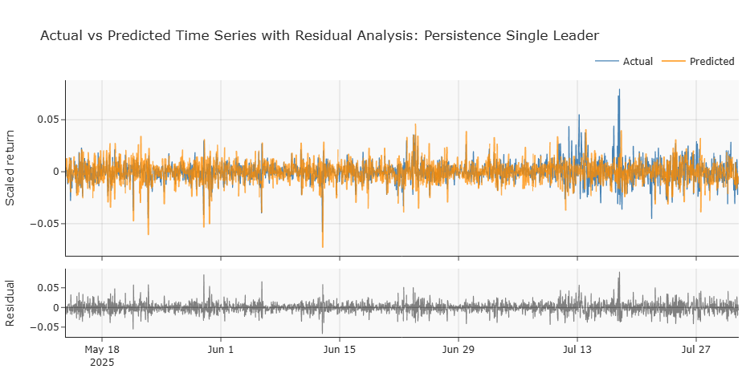
Figure 5.4. Time-series plot of simple persistence forecasts for HBARUSDT compared with actual returns.

5.2.3.2 Ridge Regression- Evaluation.
In the single-leader setting with SUIUSDT, Ridge regression has achieved RMSE = 0.0098, MAE = 0.0068, R² = 0.002, and DirAcc = 0.591. Although slightly improved relative to persistence, the model has explained almost no variance.
Extending Ridge Regression to a multi-leader input (SUIUSDT, SOLUSDT, ADAUSDT) has produced RMSE = 0.0090, MAE = 0.0068, R² = 0.009, and DirAcc = 0.491, showing negligible gain. The time-series plots for both cases (Figures 5.5 and 5.6) have shown predictions that track the overall level of returns but miss local volatility spikes, resulting in flat or smoothed forecast lines.

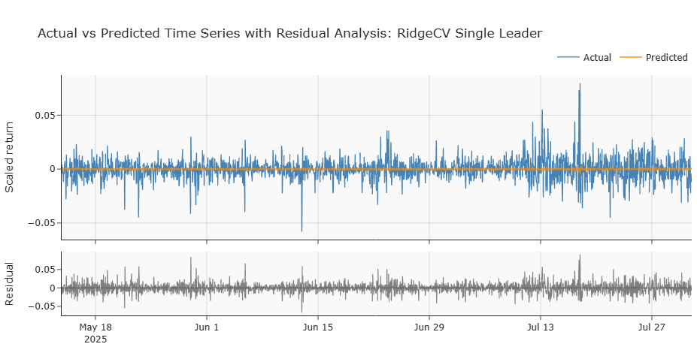
Figure 5.5. Time-series plot of Ridge regression forecasts - Single Leader.

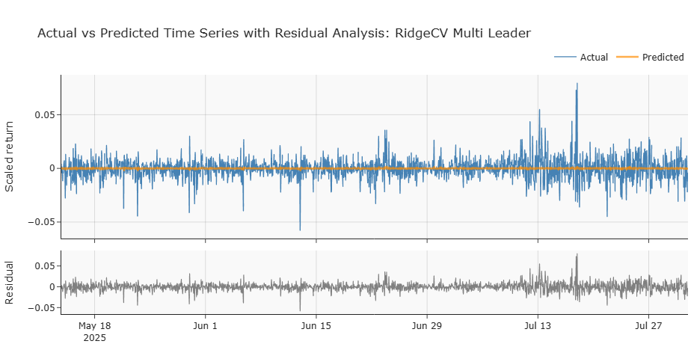
Figure 5.6. Time-series plot of Ridge regression forecasts - Multi Leader.

5.2.3.3 ARIMAX - Evaluation.
When combining the autoregressive structure of HBARUSDT with exogenous leader assets, ARIMAX(1,0,1) has produced RMSE = 0.0099, MAE = 0.0069, R² = -0.022, and DirAcc = 0.491. Restricting predictors to positive DTW-scoring leaders has not improved the performance, with RMSE = 0.0099, MAE = 0.0069, R² = -0.018, and DirAcc = 0.495. The time-series plots have shown (Figures 5.7 and 5.8) that ARIMAX forecasts tend to cluster around the mean, with weak responsiveness to volatility bursts, leaving residuals largely centred but with occasional sharp deviations during turbulent periods. These results indicated that ARIMAX, even with multiple leader inputs, was not able to capture the volatility and directional dynamics of cryptocurrency returns, reinforcing the challenge of extracting predictive value from noisy financial series (Murray et al., 2023; Bouteska et al., 2024).

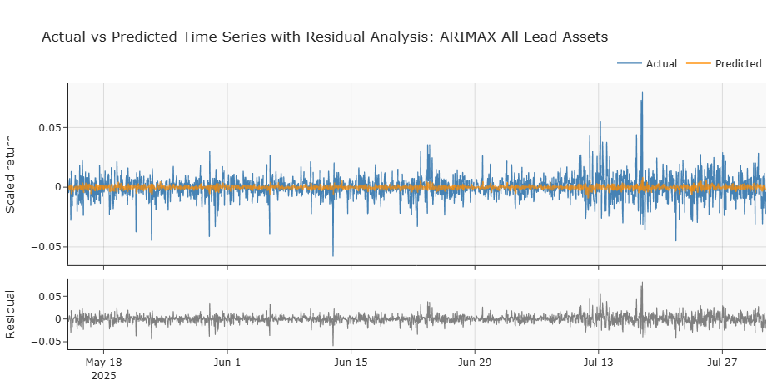
Figure 5.7. Time-series plot of ARIMAX - All Leading Assets.

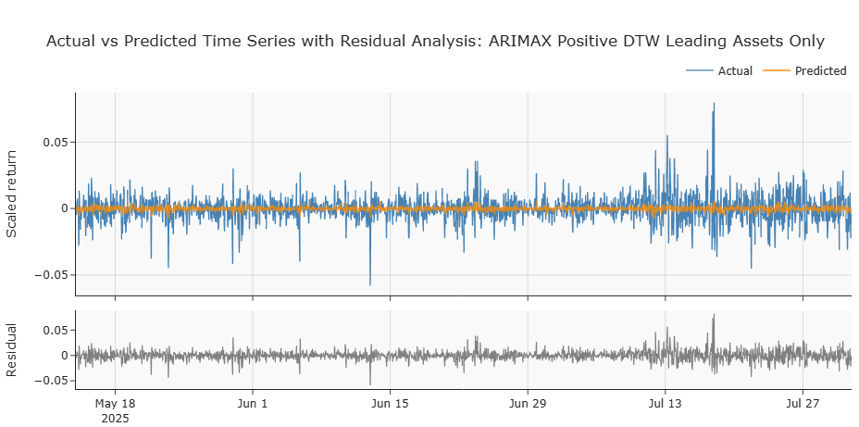
Figure 5.8. Time-series plot of ARIMAX - Positive DTW Score Leading Assets Only.

5.2.3.4 LSTM Before Hyperparameter Tuning - Evaluation.
The initial multivariate LSTM models, trained with default settings and leader assets as exogenous inputs, have shown limited predictive ability. Without PCA or tuning, the model has produced RMSE = 0.011589, MAE = 0.008217, R² = -0.188, and DirAcc = 0.446. Introducing PCA but without tuning has marginally improved performance, reducing RMSE to 0.011283 and MAE to 0.007948, with R² = -0.126 and DirAcc = 0.476. The time-series plots for the latter configurations have illustrated forecasts that smooth out volatility and lag behind sharp return swings, offering little beyond the persistence benchmarks.
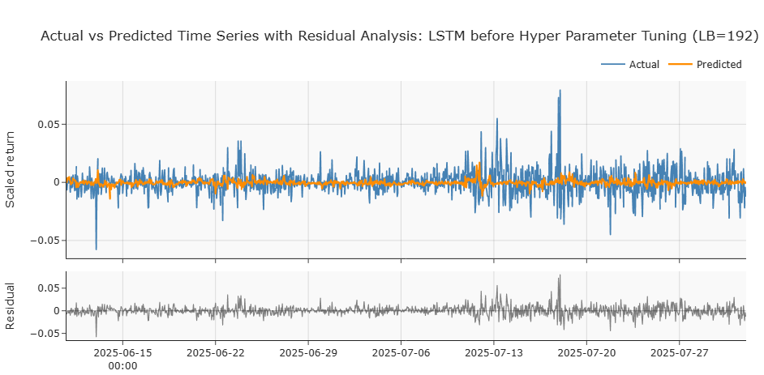
Figure 5.9. Time-series plot of LSTM forecasts without hyperparameter tuning.

5.2.3.5 LSTM After Hyperparameter Tuning - Evaluation.
Applying hyperparameter optimisation has yielded modest gains. With random search, the LSTM has reached RMSE = 0.011141, MAE = 0.007861, R² = -0.076, and DirAcc = 0.499. Grid search has given similar results, with RMSE = 0.011287, MAE = 0.008063, R² = -0.081, and DirAcc = 0.484. These tuned models have displayed slightly improved alignment with short-term return directions, as seen in the time-series plots, where forecasts occasionally track local upward or downward shifts more closely. However, larger fluctuations have continued to be underestimated.
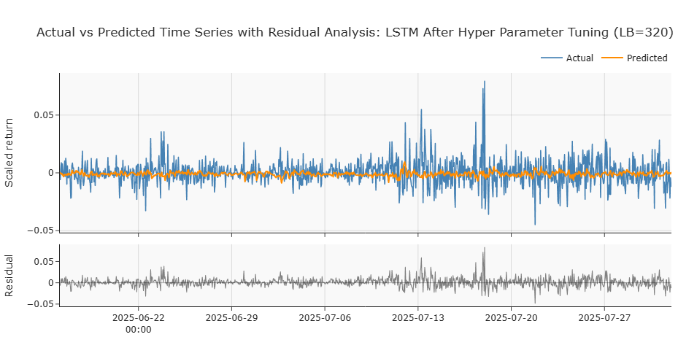
Figure 5.10. Time-series plot of LSTM forecasts after hyperparameter tuning (random and grid search).

5.2.3.6 LSTM with Rolling-Window Evaluation.
Rolling-window evaluation has been used to test robustness across changing market conditions. Three separate runs have produced broadly similar outcomes, with RMSE ranging from 0.013246 to 0.013455, MAE between 0.009616 and 0.009769, R² values near zero, and DirAcc between 0.486 and 0.506. These results have shown that while directional accuracy sometimes nudges just above 0.50, error metrics remain close to those of baseline models. The rolling time-series plots have confirmed that the LSTM can occasionally capture local directional shifts, but its forecasts continue to under-represent the amplitude of volatility spikes.
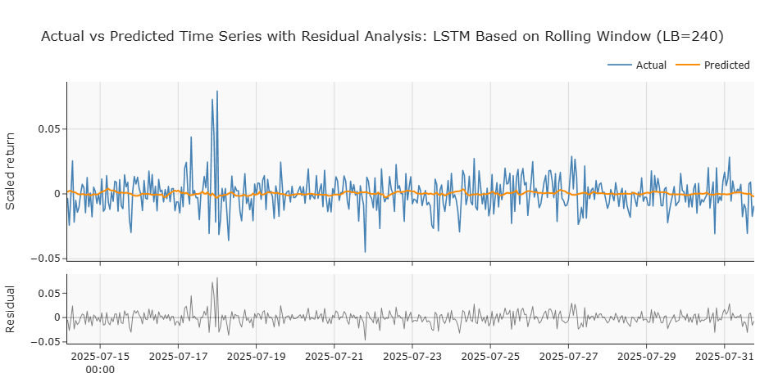
Figure 5.11. Time-series plot of rolling-window LSTM forecast.

5.3 Comparative Performance of Forecasting Models
To consolidate the individual model evaluations, the comparative performance has been visualised using a heatmap of error measures (RMSE and MAE) and a bar chart of directional accuracy (Figures 5.12 and 5.13). The heatmap has shown that all models have produced RMSE values within a narrow band of 0.009–0.014 and MAE values between 0.0068 and 0.0102, indicating only marginal differentiation in error magnitude. RidgeCV in the multi-leader setting and ARIMAX variants have achieved the lowest MAE values, while LSTM models, even after hyperparameter tuning, have not improved upon these statistical benchmarks. The bar chart of directional accuracy has provided a complementary view, revealing that most models have clustered around the 0.49–0.51 range, effectively equivalent to random guessing. The notable exception has been RidgeCV with a single leader input, which has attained a DirAcc of 0.591, suggesting modest but meaningful directional skill.

In financial return forecasting, small RMSE/MAE values have not necessarily implied practical usefulness because these metrics have been scale-dependent and dominated by the high prevalence of near-zero returns; a model that has simply shrunk predictions toward zero has often achieved low error without delivering an exploitable signal. What has mattered for economic utility has been getting the sign and timing right often enough to overcome bid - ask spreads, fees, and slippage - hence the emphasis on directional accuracy. A DirAcc materially above 0.50 has indicated potential edge, whereas values near 0.50 have been indistinguishable from chance; even figures around 0.59 have required careful consideration of trading frictions and risk to assess whether they translate into positive, risk-adjusted performance.
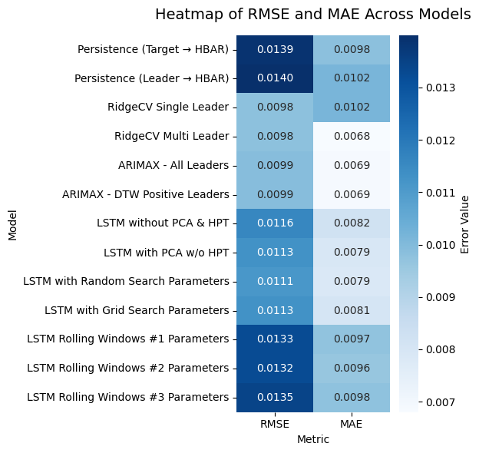
Figure 5.12. Heatmap of RMSE and MAE across all forecasting models.
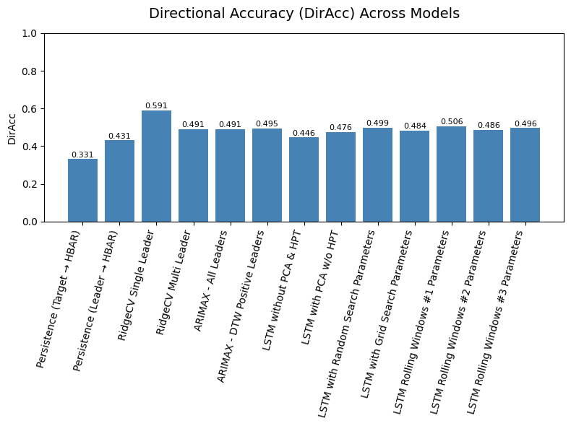
Figure 5.13. Directional accuracy (DirAcc) of forecasting models.

5.4 Discussion
This study has assessed whether clustering, lead–lag analysis, and predictive modelling can together enhance understanding of cryptocurrency dynamics. The clustering stage has shown that the selected assets behave largely as a single market cluster, with weak separability, confirming the dominance of common shocks in driving returns.

Lead–lag analysis has indicated that stable leader–follower relationships are rare. While cross-correlation and Granger causality tests have identified a few unidirectional cases (e.g., LINK → AVAX, ETH → AVAX), most pairs have displayed feedback loops. By contrast, Dynamic Time Warping has highlighted BTC, ETH, and SUI as recurrent leaders, with HBAR, LTC, and XLM appearing as persistent laggards. These findings have aligned with the expectation that large-cap assets often act as information hubs but also underscored the fragility of such leadership patterns.

Forecasting results have further illustrated the difficulty of predicting cryptocurrency returns. Persistence benchmarks have been weak, Ridge regression has offered modest error reductions, and ARIMAX has struggled with volatility. LSTM models, even after tuning and rolling-window evaluation, have failed to outperform statistical baselines, with directional accuracy remaining close to chance.
The findings have indicated that while clustering and lead–lag analysis can provide descriptive insight into market structure and temporal dependencies, these signals have not translated reliably into predictive accuracy. The study has therefore highlighted both the potential and the limits of integrated data-driven methods in short-horizon cryptocurrency forecasting.

5.5 Conclusion
This thesis has addressed three research questions concerning clustering, lead–lag dynamics, and forecasting in cryptocurrency markets.

5.5.1 RQ1 - Clustering
The first question asked whether Dynamic Time Warping (DTW) can reveal meaningful groupings of cryptocurrencies with similar behaviours. The findings have shown that while DTW successfully measured similarity across return series, the resulting clusters displayed weak separability, with silhouette scores close to zero. This outcome has confirmed that the examined assets behave as a single broad market cluster, driven by strong co-movement rather than distinct subgroups.

5.5.2 RQ2 - Lead–lag dynamics
The second question investigated whether cryptocurrencies exhibit consistent leader–follower relationships. Cross-correlation and Granger causality analyses have provided limited evidence of stable unidirectional leadership, with most relationships appearing bidirectional. Nevertheless, DTW-based lag analysis has identified BTC, ETH, and SUI as recurrent leaders and HBAR, LTC, and XLM as persistent laggards. These results have indicated that while large-cap assets often emerge as leaders, such patterns have been fragile and dependent on market conditions.

5.5.3 RQ3 - Forecasting
The third question explored whether predictive models, including LSTM networks enhanced with leader inputs, could improve forecasting accuracy compared to simpler baselines. The results have shown that neither Ridge regression nor ARIMAX achieved substantial gains, and LSTM networks, even after hyperparameter tuning and rolling-window evaluation, have not significantly outperformed persistence models. Directional accuracy has remained close to random chance, highlighting the challenge of extracting predictive value from short-horizon returns. This difficulty is further illustrated in Figure 5.14, where the 720-hour rolling mean of HBARUSDT log returns has displayed abrupt regime shifts, sharp reversals, and extended periods of instability. Such dynamics have underscored why even advanced machine learning models have struggled to capture reliable predictive signals in cryptocurrency time series.
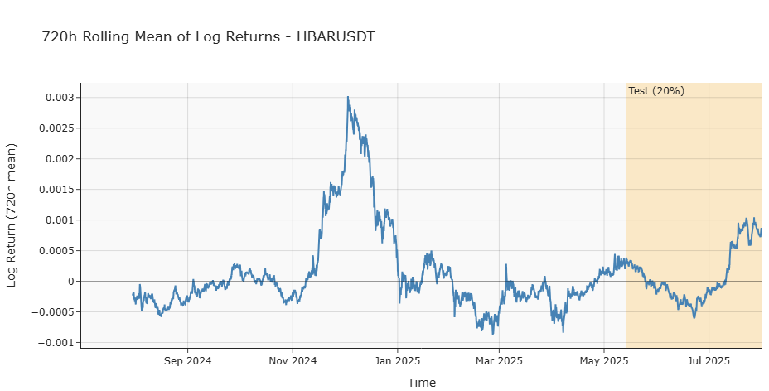
Figure 5.14: 720-hour rolling mean of HBARUSDT log returns.

Taken together, the study has shown that clustering and lead–lag analysis have provided valuable descriptive insights into cryptocurrency markets but have not easily translated into predictive accuracy. These techniques have mapped co-movement structure and episodic precedence, clarifying where and when assets have tended to move together; however, the detected relationships have been regime-dependent and time-unstable, which has limited their out-of-sample utility. Rolling-window evaluations and sensitivity checks have corroborated that apparent leadership has often collapsed to near-synchronous movement at zero lag, reducing the incremental information available for forecasting.

The limited benefits of integrating leader signals into forecasting models - illustrated by the unstable patterns visible in Figure 5.14 - have underlined the volatility and noise inherent in cryptocurrency returns. Across folds and horizons, the sign and magnitude of leader effects have shifted, so that models have captured contemporaneous correlation rather than durable precedence. The contribution of this research has therefore lain in demonstrating an integrated and reproducible framework that has combined clustering, lead–lag detection, and predictive modelling with strict time-ordering and leakage controls. While its results have emphasised the limits of short-horizon predictability, the framework has established a transparent baseline against which extensions - such as longer horizons, richer feature sets, and explicit regime modelling - can be systematically assessed.

5.6 Future Work
The findings of this thesis have highlighted several avenues for future research. Since the clustering results have largely indicated that cryptocurrencies move together as a single market cluster, subsequent work could shift attention to the treatment of outliers. By identifying and excluding atypical assets that differ strongly from the majority, clustering might yield clearer substructures that are otherwise masked.

Another direction has been the development of more robust forecasting approaches, such as creating pre-trained models based on broader historical datasets and a larger variety of cryptocurrencies, enabling better generalisation across regimes. Expanding the model set beyond LSTM - such as GRU, Temporal Convolutional Networks, or transformer-based models - has also offered promising opportunities.

The integration of exogenous features has represented a further extension. While this thesis has focused on price-based signals and leader–lag relationships, incorporating macroeconomic indicators or market microstructure variables could enhance explanatory power. Social signals may also hold potential: linking live streams of social media data from platforms such as X (formerly Twitter) to asset-specific models could allow for more responsive forecasts.

Finally, regime-switching behaviour has remained a central challenge. The rolling evaluation has shown that predictive accuracy is highly sensitive to volatility and structural breaks. Future work could therefore test models that explicitly allow for such transitions, including Markov regime-switching or models with volatility clustering.

Taken together, these avenues have shown that while short-horizon cryptocurrency forecasting remains difficult, combining more robust modelling strategies, richer data sources, and explicit treatment of regime changes may gradually improve both the descriptive and predictive value of data-driven approaches.

6. References
Abadi, M., Barham, P., Chen, J., Chen, Z., Davis, A., Dean, J., Devin, M., Ghemawat, S., Irving, G., Isard, M., Kudlur, M., Levenberg, J., Monga, R., Moore, S., Murray, D., Steiner, B., Tucker, P., Vasudevan, V., Warden, P. and Wicke, M. (2016). TensorFlow: A System for Large-Scale
Machine Learning. Available at: https://www.usenix.org/system/files/conference/osdi16/osdi16-abadi.pdf.

Abuzaid, A. and Eyad Alkronz (2024). A COMPARATIVE STUDY ON UNIVARIATE OUTLIER WINSORIZATION METHODS IN DATA SCIENCE CONTEXT. Statistica Applicata - Italian Journal of Applied Statistics, [online] (1). doi:https://doi.org/10.26398/IJAS.0036-004.

Aghabozorgi, S., Shirkhorshidi, A.S. & Wah, T.Y. (2015) ‘Time-series clustering - A decade review’, Information Systems, 53, 16-38. https://doi.org/10.1016/j.is.2015.04.007. Accessed 7 September 2025.
AlMadany, N.N., Hujran, O., Al Naymat, G. & Maghyereh, A. (2024) ‘Forecasting cryptocurrency returns using classical statistical and deep learning techniques’, International Journal of Information Management Data Insights, 4(2), 100251. https://doi.org/10.1016/j.jjimei.2024.100251. Accessed 7 September 2025.
Bennett, S., Cucuringu, M. and Reinert, G. (2022). Lead–lag detection and network clustering for multivariate time series with an application to the US equity market. Machine Learning, 111(12), pp.4497–4538. https://doi.org/10.1007/s10994-022-06250-4.

Binance (2025) Terms. Available at: https://www.binance.com/terms (Accessed 7 September 2025). Binance
Binance (n.d.) Binance API. Available at: https://www.binance.com/en/binance-api (Accessed 7 September 2025). Binance
Bouteska, A., Abedin, M.Z., Hajek, P. and Yuan, K. (2024). Cryptocurrency price forecasting – A comparative analysis of ensemble learning and deep learning methods. International Review of Financial Analysis, 92, p.103055. doi:https://doi.org/10.1016/j.irfa.2023.103055.

Chapman, P., Clinton, J., Kerber, R., Khabaza, T., Reinartz, T., Shearer, C. & Wirth, R. (2000) CRISP-DM 1.0: Step-by-step data mining guide. SPSS. Available at: https://www.kde.cs.uni-kassel.de/wp-content/uploads/lehre/ws2012-13/kdd/files/CRISPWP-0800.pdf (Accessed 7 September 2025).
Chatfield, C. (2003) The Analysis of Time Series: An Introduction. 6th edn. Chapman & Hall/CRC. https://doi.org/10.4324/9780203491683. Accessed 7 September 2025.
Cui, J., Maghyereh, A. Time–frequency co-movement and risk connectedness among cryptocurrencies: new evidence from the higher-order moments before and during the COVID-19 pandemic. Financ Innov 8, 90 (2022). https://doi.org/10.1186/s40854-022-00395-w

d’Aquin, M., Troullinou, P., O’Connor, N.E., Cullen, A., Faller, D. & Holden, N. (2018) ‘Towards an “Ethics by Design” methodology for AI research projects’, Proceedings of the 2018 AAAI/ACM Conference on AI, Ethics, and Society (AIES’18), 366–372. https://doi.org/10.1145/3278721.3278765. Accessed 7 September 2025.
Fan, J. & Yao, Q. (2003) Nonlinear Time Series: Nonparametric and Parametric Methods. Springer, New York. https://doi.org/10.1007/b97702. Accessed 7 September 2025.
Granger, C.W.J. (1969) ‘Investigating causal relations by econometric models and cross-spectral methods’, Econometrica, 37(3), 424-438. Available at: https://www.jstor.org/stable/1912791 (Accessed 7 September 2025).
Guan, C., Liu, W., Yu, Y. & Ding, D. (2024) ‘Tokenomics in the Metaverse: understanding the lead–lag effect among emerging crypto tokens’, Financial Innovation, 10(1), 1–19. https://doi.org/10.1186/s40854-023-00594-z. Accessed 7 September 2025.
Guo, L., Sang, B., Tu, J. & Wang, Y. (2021/2022) ‘Cross-cryptocurrency return predictability’, SSRN Electronic Journal. https://doi.org/10.2139/ssrn.3974583. Accessed 7 September 2025.
Huber, P. and Elvezio Ronchetti (2009). Robust statistics. Available at: https://toc.library.ethz.ch/objects/pdf/e01_978-0-470-12990-6_01.pdf. Accessed 7 September 2025.‌

Jolliffe, I.T. (2002) Principal Component Analysis. 2nd edn. New York: Springer. Available at: http://cda.psych.uiuc.edu/statistical_learning_course/Jolliffe%20I.%20Principal%20Component%20Analysis%20(2ed.,%20Springer,%202002)(518s)_MVsa_.pdf.

Jolliffe, I.T. and Cadima, J. (2016). Principal component analysis: a review and recent developments. Philosophical Transactions of the Royal Society A: Mathematical, Physical and Engineering Sciences, Available at: doi:https://doi.org/10.1098/rsta.2015.0202.

‌Molnar, C. (2019) Interpretable Machine Learning. Online book. Available at: https://christophm.github.io/interpretable-ml-book/ (Accessed 7 September 2025). christophm.github.ioGitHub
Murray, K., Rossi, A., Carraro, D. & Visentin, A. (2023) ‘On forecasting cryptocurrency prices: A comparison of machine learning, deep learning, and ensembles’, Forecasting, 5(1), 196-209. https://doi.org/10.3390/forecast5010010. Accessed 7 September 2025.
OpenAI (2025). ChatGPT. [online] ChatGPT. Available at: https://chatgpt.com/.

Pedregosa, F., Varoquaux, G., Gramfort, A., Michel, V., Thirion, B., Grisel, O., Blondel, M.,
Prettenhofer, P., Weiss, R., Dubourg, V., Vanderplas, J., Passos, A., Cournapeau, D., Brucher, M.,
Perrot, M. & Duchesnay, E. (2011) Scikit-learn: Machine Learning in Python, Journal of Machine Learning Research, [online] 12, pp.2825–2830. Available at: https://www.jmlr.org/papers/volume12/pedregosa11a/pedregosa11a.pdf.

Petitjean, F., Ketterlin, A. & Gançarski, P. (2011) ‘A global averaging method for dynamic time warping, with applications to clustering’, Pattern Recognition, 44(3), 678-693. https://doi.org/10.1016/j.patcog.2010.09.013. Accessed 7 September 2025.
Rousseeuw, P.J. (1987) ‘Silhouettes: A graphical aid to the interpretation and validation of cluster analysis’, Journal of Computational and Applied Mathematics, 20, 53-65. https://doi.org/10.1016/0377-0427(87)90125-7. Accessed 7 September 2025.
Seabold, S. and Perktold, J. (2010). Statsmodels: Econometric and Statistical Modeling with Python. [online] PROC. OF THE 9th PYTHON IN SCIENCE CONF. Available at: https://pdfs.semanticscholar.org/3a27/6417e5350e29cb6bf04ea5a4785601d5a215.pdf.

Shearer, C. (2000). The CRISP-DM model: the new blueprint for data mining. Journal of Data Warehousing, 5(4), pp.13–22.

Sifat, I.M., Mohamad, A. & Yousf, M. (2019) ‘Lead–lag relationship between Bitcoin and Ethereum’, Research in International Business and Finance, 50, 306–321. https://doi.org/10.1016/j.ribaf.2019.06.001. Accessed 7 September 2025.
Sigaki, H.Y.D., Perc, M. & Ribeiro, H.V. (2019) ‘Clustering patterns in efficiency and the coming-of-age of the cryptocurrency market’, Scientific Reports, 9, 1440. https://doi.org/10.1038/s41598-018-37773-3. Accessed 7 September 2025.

Šťastný, T. (2022) ‘Clustering and modelling of the top 30 cryptocurrency prices using dynamic time warping and machine learning methods’, Mathematics, 10(19), 3672. https://doi.org/10.3390/math10193672. Accessed 7 September 2025.

Tripathi, S., Muhr, D., Brunner, M., Jodlbauer, H., Dehmer, M. and Emmert-Streib, F. (2021). Ensuring the robustness and reliability of data-driven knowledge discovery models in production and manufacturing. Frontiers in Artificial Intelligence, https://doi.org/10.3389/frai.2021.576892.

Wątorek, M., Skupień, M., Kwapień, J. and Drożdż, S. (2023). Decomposing cryptocurrency high-frequency price dynamics into recurring and noisy components. Chaos: An Interdisciplinary Journal of Nonlinear Science, [online] 33(8). doi:https://doi.org/10.1063/5.0165635.
Wu, J., Zhang, R., Huang, X., Zhou, F. & Chandra, R. (2024) ‘Review of deep learning models for crypto price prediction: implementation and evaluation’, arXiv preprint arXiv:2405.11431. Available at:https://arxiv.org/pdf/2405.11431 (Accessed 7 September 2025).
Zhao, J. & Itti, L. (2016) ‘shapeDTW: Shape dynamic time warping’, arXiv preprint arXiv:1606.01601 (with extended PR version, 2017). Available at: https://arxiv.org/pdf/1606.01601
(Accessed 7 September 2025).

